1. (5 pts) Write a short essay on Hers’ disease. Your essay should discuss:

i) The normal function of the enzyme that is affected by this genetic disease, and how this enzyme is regulated in a normal individual.

ii) The consequence of loss of function to the individual.

iii) Whether males or females will be more likely to inherit this disease.

2. (5 pts) What compound will generate more energy from oxidation in metabolism, a 6 carbon sugar (e.g. glucose) or a six carbon fatty acid? Remember that all the carbons in either molecule will be converted to CO2 during oxidation so you want to think about the relative energy of the starting compounds.



3. (5 pts) A liver cell initially has high ATP levels. However, due to cellular activity its ATP is converted to ADP. How is glycolysis regulated during these events? Why is this regulation sensible?

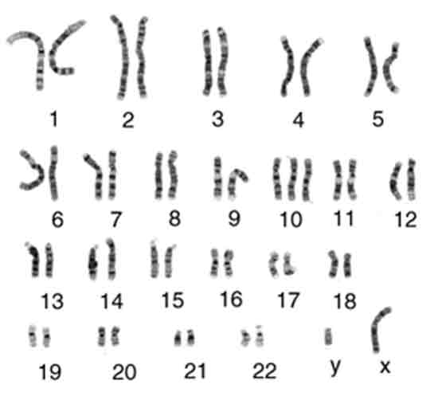4. (5 pts) The image to the right shows a human karyotype.

i) Is this individual a male or female?

ii) Was the image of these chromosome acquired just before mitosis begins, or from the daughter cells? Why?

iii) Does this individual have the normal complement of human chromosomes? If not, how do they differ?

5. (5 pts) A cell that recently divided acquired a mutation that inactivated cyclin B. What happens the next time the cell attempts to undergo mitosis?

6. (5 pts) Taxol is used to treat a number of cancers. It works by stabilizing microtubules, i.e. making it difficult for the αβ-tubulin subunits to leave the microtubule. Where was taxol first isolated (cite your source)? Why do you think it is effective at treating cancer?

7. (5 pts) One histone modification is acetylation of lysine residues, the structure of lysine and acetylated lysine are shown on the right. Why might lysine acetylation reduce the binding of histones to the DNA?



8. (10 pts) Two pea plants with smooth peas were bred to each other. The peas from the first generation (F1) were 50% smooth and 50% wrinkled. What are the possible genotypes of the parent plants that would account for the observed data?

9. (10 pts, **bonus**) Complete the metabolism puzzle on the next page. After your puzzle is complete you can either tape the pieces to a sheet of paper and submit that or take a picture of the assembled puzzle.

**Instructions:**

Cut out all of the pieces and then assemble them on a separate piece of paper such that you represent the energy generating pathways in the cell. Pay attention to the cellular location of the pathways, where the intermediates in the pathway are found, and the relative levels of energy production by each pathway. If a compound is listed more than once, it is in two different compartments in the cell (e.g. cytoplasm and mitochondrial matrix).

