1. (10 pts) Some individuals cannot produce sufficient quantities of growth hormone which causes a number of problems during development. You want to insert the coding information for human growth hormone into a plasmid so that you can produce the growth hormone in bacteria. The DNA sequence (one strand only) and the protein sequence of the growth hormone are shown below. Give the sequence of the left and right primers that you would use to generate a PCR product that could be inserted into the plasmid using restriction enzymes. Assume that the total length of your primers are 12 bases. Also assume that you would use the same plasmid that we have used for HIV protease, i.e. the final PCR product should have an EcoR1 site on the left and a BamHI site on the right.

GGTGTGATGTTGGTTGTTGATCGTTACGCTTTTAGCGGTGTGTAATTCAC
MetLeuValValAspArgTyrAlaPheSerGlyVal
The start codon is in bold and the stop codon is underlined. Note that the plasmid already has a start and stop codon, so it is not necessary to include those in the PCR product. You just need to amplify the 2nd codon (Leu) to the last one (Val).
2. (5 pts) The recognition sequences for TaqI is T^CGA and for ClaI is AT^CGAT
i) The following DNA was cut (digested) with ClaI. How many pieces (fragments) of DNA would be produced and what are their sizes (The lengths of the top and bottom strand will be different, so just give the size of the top strand).
TTGGATCGTATGCGGATCGATGTATAAT
AACCTAGCATACGCCTAGCTACATATTA
ii) Fragments that are produced by one enzyme can always be ligated to fragments produced by the same enzyme. Can fragments that are produced by TaqI be ligated to fragments produced by ClaI? Why or why not?
3. (10 pts) Hemophiliacs have a genetic deficiency such that they cannot make a protein required for blood clotting. This protein can be purified from cows and administered to hemophiliacs.
i) This treatment works well initially, but eventually the treatment is ineffective. Suggest a possible reason for this. [Hint: The amino acid sequence of the clotting protein from cows is different than humans].
ii) You could solve the above problem by obtaining the clotting protein from donated human blood, but that is very expensive process and the supply is limited. Consequently you want to express the protein in bacteria. You will use the same expression plasmid that we discussed in class, but instead of using PCR to obtain the codons from human DNA you will generate the DNA using chemical synthesis. The amino acid sequence of the clotting factor is:
Met-Arg-Leu-Phe-Trp
4. (5 pts) Why is it not useful to vaccinate someone against HIV by the injection of HIV virus?
5. (5 pts) Suggest a way to produce an HIV vaccine using the methods that we have been recently discussing in class. You can assume that the entire RNA sequence of HIV is known and that the sequences that code for the coat proteins are known. Coat proteins are on the surface of the virus and would be recognized by antibodies that would be produced after vaccination.
6. (5 pts) Assuming you were successful in producing a vaccine against HIV, what property of the viral lifecycle would likely make the vaccine ineffective?
7. (5 pts) You would like to sequence mutations in the HIV protease gene and you believe that the mutations are located within the first 20 amino acids. What sequencing primer could you use? Give an example sequence.
8. (5 pts) You order the DNA primer for sequencing, but discover that you have sent the company the sequence of the complementary strand, can you still use it to sequence your HIV protease mutant? Why or why not?
9. (4 pts) You are doing DNA sequencing and have run out of ddTTP. Can you obtain the sequence using just the other three dideoxybases? If so, how would the data change?
10. The DNA sequence data for a wild-type protein and a mutant are presented below. Translation of the wild-type sequence by Expasy is also shown below (a “-“ is a stop codon).
i) What is the correct reading frame?
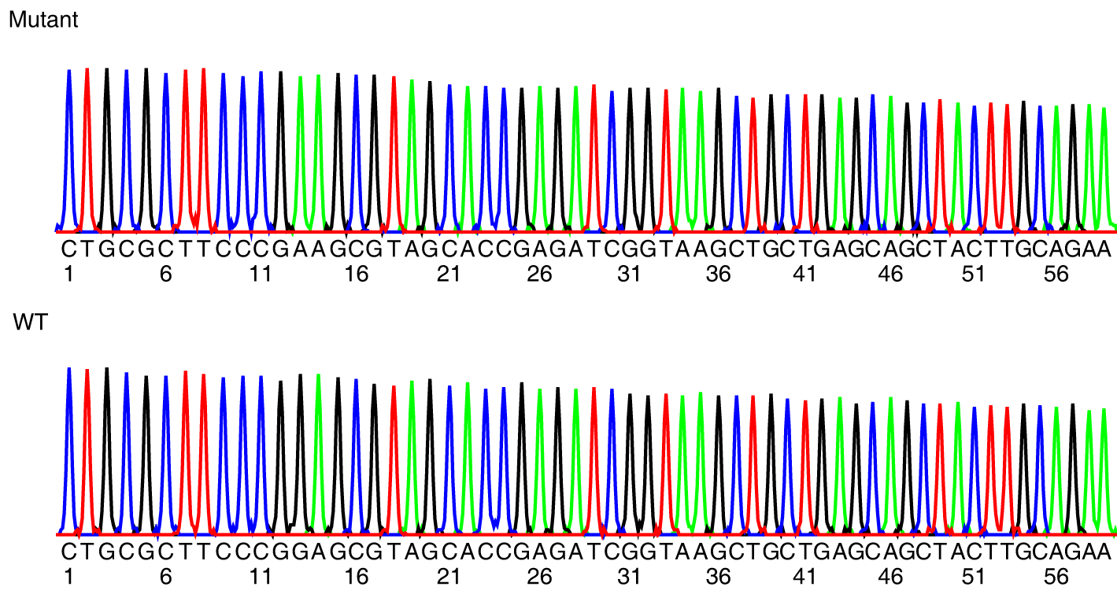
ii) What is the mutation?

5'3' Frame 1
ctgcgcttcccggagcgtagcaccgagatcggtaagctgctgagcagctacttgcagaa
L R F P E R S T E I G K L L S S Y L Q
5'3' Frame 2
ctgcgcttcccggagcgtagcaccgagatcggtaagctgctgagcagctacttgcagaa
C A S R S V A P R S V S C - A A T C R
5'3' Frame 3
ctgcgcttcccggagcgtagcaccgagatcggtaagctgctgagcagctacttgcagaa
A L P G A - H R D R - A A E Q L L A E

