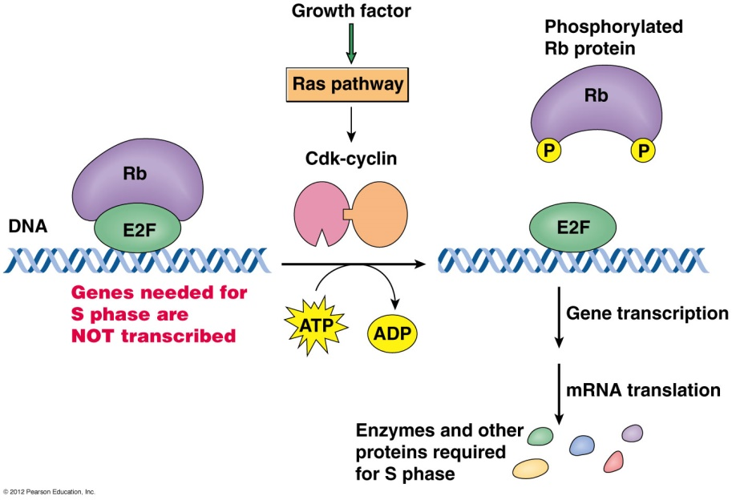**Lecture 33: Mitosis and Meiosis**

**RB** (retinoblastoma) – Revisited: suppresses activity of E2F transcription factor, until cyclin D is activated.Mutations in RB lead to tumors in the eye (retinoblastomas) because E2F is always active, leading to uncontrolled cell division by the activation of genes required for cell cycle.

**Mitosis:**

* Goal – duplicate DNA so that daughter cells has the same DNA as the parent.
* Exact DNA copy made. One chromatid becomes a pair of sister chromatids. These are separated into daughter cells.



* 2N chromosomes before, 2N chromosomes after.

**Consists of 5 Steps**

1. Prophase – chromosomes condense, spindle forms. Spindle is organized by **centrosomes**.

2. Prometaphase: Nuclear membrane disappears. Spindle fibers (**microtubules)** attach to **kinetichore** on duplicated chromosomes.

3. Metaphase: Chromosomes align at the center of the cell

4. Anaphase: Sister chromatids separate, pulled to opposite poles of cell by microtubules.

5. Telophase: Nuclear membrane reappears, spindle disappears. Daughter cells formed by cytokinesis.

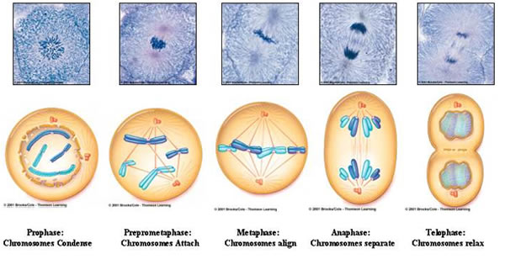

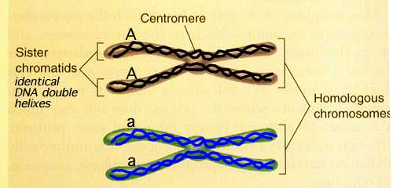**Homologous chromosomes:** Contain the same genes in the same location. Humans have 23 pairs.

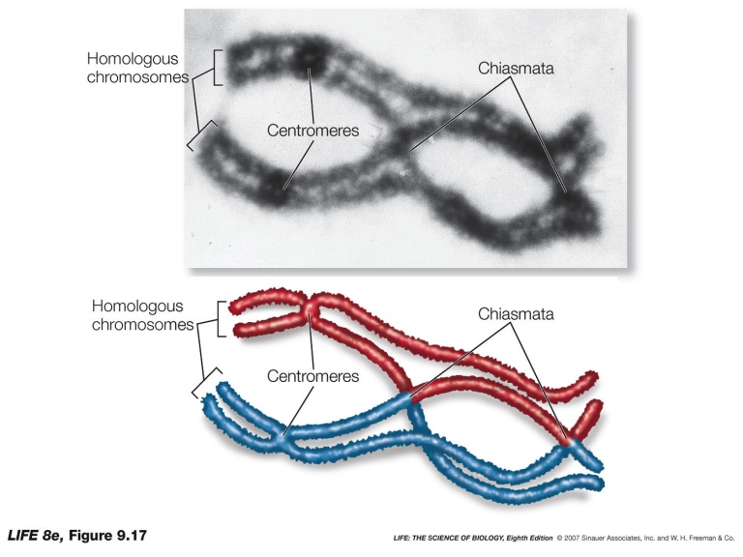**Allele:** Indicates a different DNA sequence in a gene. Genes on homologous chromosomes can be different alleles. The different alleles may result in different amino acid sequences with different functional properties. In the diagram above “A” and “a” represent the same gene, but with different sequences. e.g. coding for red and white flower color.

**Meiosis:** Formation of Gametes (sperm and egg):

* 2n → n
* Exchange of DNA occurs between maternal and paternal chromosome – new sequences are generated.
* Consists of two steps:
* Meiosis I: DNA duplication, crossing over, separation of homologous chromosomes.
* Meiosis II: Separation of sister chromatids.

.**Crossing over:**

* Arms of chromosome that have identical sequences pair and swap strands, forming **chiasmata**.
* Breakage of swapped strands interchanges the strands on each chromatid. Transferring some of the maternal chromosome to the paternal, and the reverse.



* Double crossover has occurred in middle figure, single crossover illustrated in bottom figure.

**Meiosis** I: Steps are the same as mitosis. Diagram begins after replication of DNA:

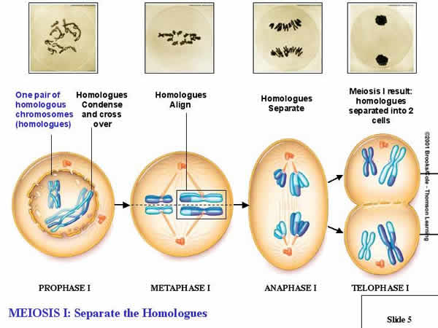

**Meiosis II – Separation of chromatids**: 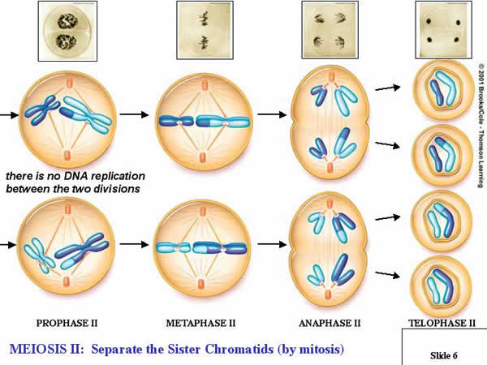

**Key Points:**

* Gametes are haploid, with n chromosomes
  + Complete set of autosomes
  + One X chromosome (provided by egg)
  + One X or one Y chromosome (provided by sperm)
* Recombination during prophase I exchanges information (DNA sequences) between maternal and paternal chromosome.
* Chromosomes segregate independently, a mixture of maternal and paternal chromosomes can be found in the same gamete.



**Chromosomal Movement during Mitosis and Meiosis.**

Filamentous proteins serve a number of important roles in the cell, forming the cytoskeleton – a network of fibers that maintain (and change) the shape of the cell. The major class of filamentous proteins are:

1. 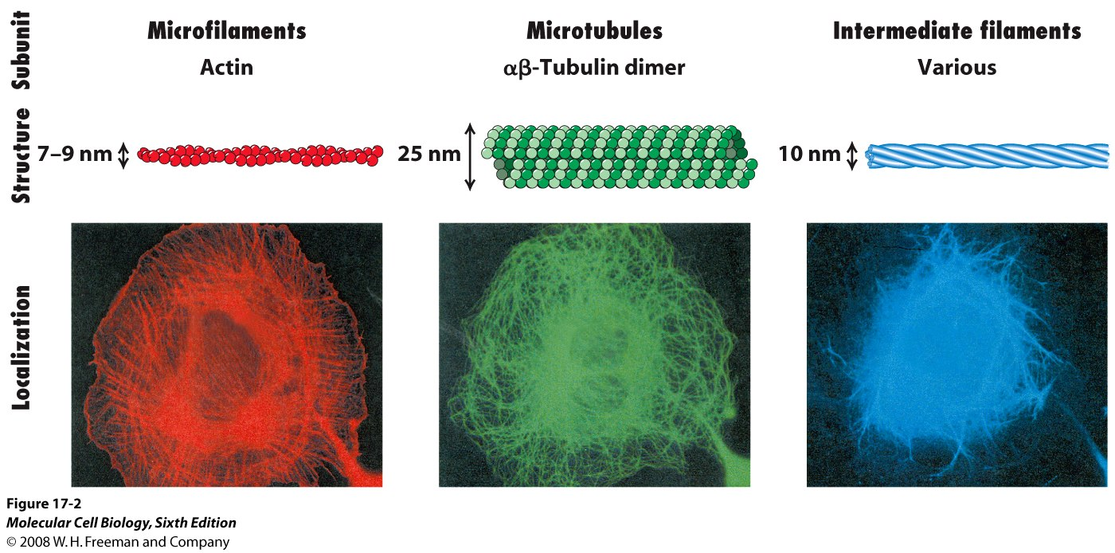Actin: In combination with myosin, can use ATP to move vesicles and organelles in cells, or contract muscle fibers in muscle tissue.
2. Microtubules: In combination with kinesins, ATP is used to move vesicles in cells, or chromosomes during mitosis and meiosis.
3. Intermediate filaments: Structural role in cells.

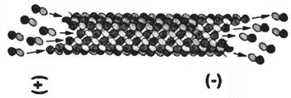**Assembly of Actin and Microtubules:**

* Both of these assemble from small subunits, G-actin, or α & β dimers of tubulin.
* Assembly only occurs at the ends of the polymer.
* The ends of the polymer are not equal, one end is defined as the – end the other the + end.

**Movement of Chromosomes**

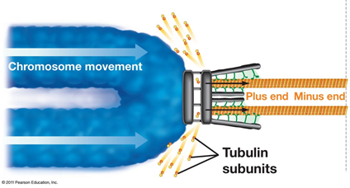

* The spindle fibers shorten, pulling the chromosomes to the centrosome.
* Tubulin subunits are released from the end closest to the chromosome.
* As subunits are released, the attachment assembly keeps the chromosome attached to the microtubule.

**Separation of cells.**

* A specialized kinesin can use ATP to push the two cells apart by moving microtubules apart.

