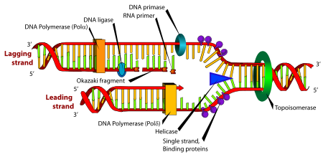**Lecture 32: Replication of Chromosomes, Histone modification, Mitosis.**

**What to do at the ends?**

* The lower strand can be replicated to its end as part of the leading strand synthesis.
* The upper, lagging, strand cannot because it cannot be primed.
* 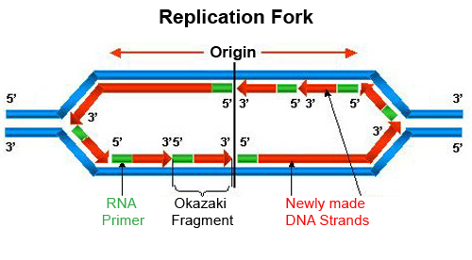Chromosomes would shorten after each replication.

Polδ = Pol III Polα = Pol I Gyrase = Toposiomerase



**Telomerase –** A reverse transcriptase with its own template.

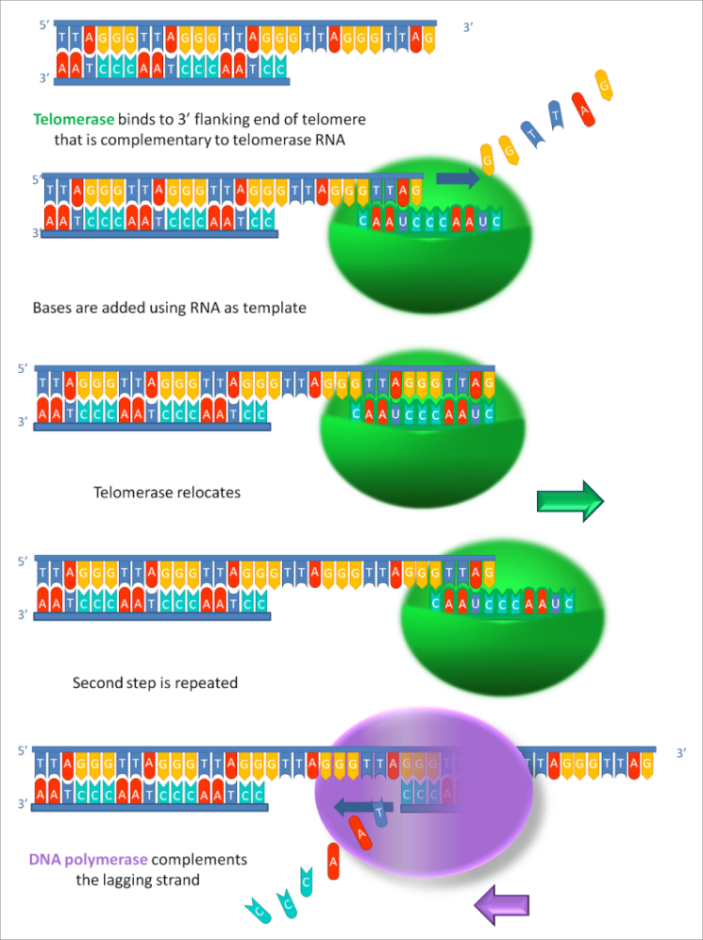



**Telomerase and Cancer:**

* normal cells produce low levels of telomerase and have a limited number of cell divisions.
* Cancer cells often have elevated levels of telomerase, allowing them to divide an infinite number of times.

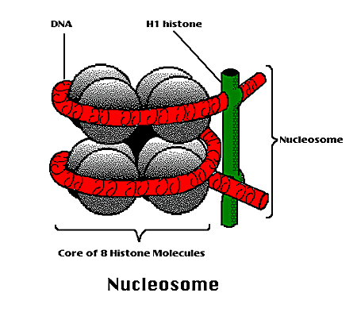**Histone Modification and Regulation of Gene Expression:**

* 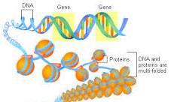DNA that is highly condensed is not available for transcription.
* Modification of histones can restructure the chromosome, allowing or inhibiting transcription.
* Common modification of histones include:
  + Acetylation of lysine residues
  + Phosphorylation of Serine and Tyrosine residues
  + Methylation of lysine residues.

The site of and type of modification can affect whether the DNA is accessible for transcription. For example, methylation of lysine at position 4 or 27 in a histone causes different conformational changes in the histone, affecting DNA binding.



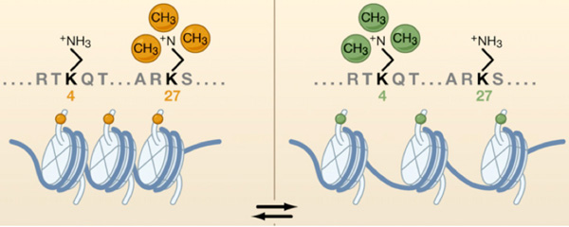

**Comparison of Regulation and Diversity of Eukaryotic and Prokaryotic Proteins:**

**Prokaryotic Cells Eukaryotic Cells**

Transcriptional Control

Repressors Repressors

Activators Activators (enhancers/transcription factors)

**DNA accessibility (histone modification)**

mRNA Stability and Processing

mRNA stability (poly A)

Alternative spicing

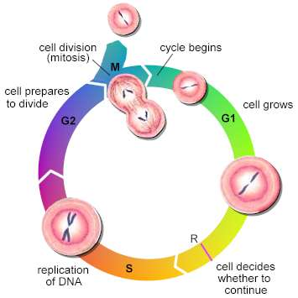**Replication of Body (somatic) cells (Chapter 13):**

* Maintain diploid number of chromosomes 2n → 2n
* Exact copy of Genetic material in daughter cells.

**Cell cycle:**

G1 – cell growth

S – replication of DNA, chromosomes are duplicated.

G2 – Prior to division

M – **mitosis**, separation of chromosomes.

**Interphase** = G1-S-G2

* Cell cycle regulated by cyclins and cyclin dependent protein kinases (CDK).
* The cyclin-CDK complex act to kinase proteins involved in progression through cell cycle.



* Order of expression of cyclins is:

D (G1) → E (G1/S) → A (S/G2) → B (M)

The appearance of the next cyclin leads to the destruction of the previous:

**Mitosis:**



1. Prophase – chromosomes condense, spindle forms. Spindle is organized by **centrosomes**.

2. Prometaphase: Nuclear membrane disappears. Spindle fibers (**microtubules)** attach to **kinetichore** on duplicated chromosomes

3. Metaphase: Chromosomes align at the center of the cell

4. Anaphase: Sister chromatids separate, pulled to opposite poles of cell by microtubules.

5. Telophase: Nuclear membrane reappears, spindle disappears. Daughter cells formed by cytokinesis.

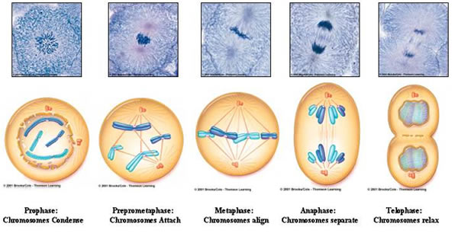

**Checkpoints in Cell Division:**

G1 checkpoint (R) – DNA must be intact for replication

G2 checkpoint: - DNA must be fully replicated and not damaged.

**Cancer and Cell Division:**

**p53 –** detects DNA damage and arrests cell division.

**RB** (retinoblastoma) – suppresses activity of E2F transcription factor, until cyclin D is activated.

Mutations in RB lead to tumors in the eye (retinoblastomas) because E2F is always active, leading to uncontrolled cell division by the activation of genes required for cell cycle.