**Lecture 27 – Introduction to Cellular Signaling**

|  |  |  |  |
| --- | --- | --- | --- |
| **Hormone** | **Chemical nature** | **Effect** | **Signaling Pathway** |
| glucagon | peptide | Release of glucose from liver storage | G-protein coupled receptor/protein phos. |
| Adrenaline/epinephrine | File:Epinephrine structure with descriptor.svg | Fight-or-flight hormone. | G-protein coupled receptor/protein phos. |
| insulin | Small protein | Storage of excess glucose in liver | Tyrosine kinase/prot phosphorylation |
| Growth hormone | Protein | Stimulates cell division | Tyrosine kinase/prot phosphorylation |
| Estrogen | File:Estriol v2.png | Activation of genes involved in female reproduction. | Direct binding to proteins that affect transcription. |

**Protein Phosphorylation:**



Kinase: An enzyme that transfers a phosphate group from ATP to an enzyme. Protein kinases play an important role in signaling. Phosphate added to serine or tyrosine. Usually causes an allosteric change that activates or inactivates the enzyme.

Phosphatase: An enzyme that removes a phosphate from a group by hydrolysis. **Neither ATP or ADP are involved in the reaction.**

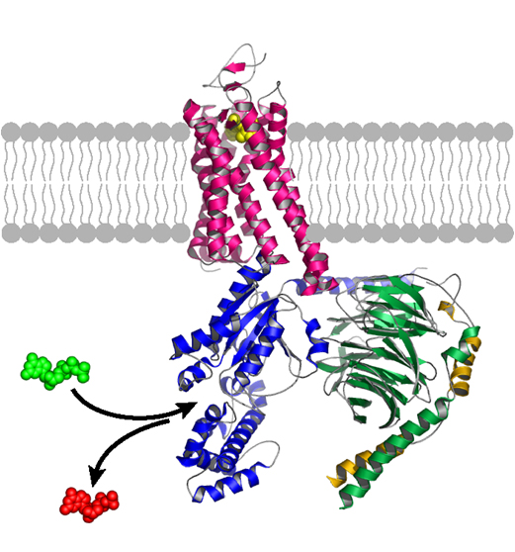

**Signaling from the Outside:**

**G-Protein Coupled Receptors:**



* Conformational change in receptor due to ligand binding.
* Conformational change in G-protein due to GDP/GTP Exchange.
* Active G-protein then activates adenyl cyclase – produces cyclic AMP (cAMP), a second messenger.
* cAMP activates protein kinases that turn on/off pathways.

**Example**: Glucose release from glycogen:

1. When blood sugar is low, hormone glucagon is released.
2. Binds to its receptor, a G-coupled protein.
3. cAMP levels increase
4. Protein kinase is activated



1. Glycogen phosphorylase becomes phosphorylated, activating it.
2. Glucose is released from glycogen as glucose-1P, converted to glucose and enters blood.

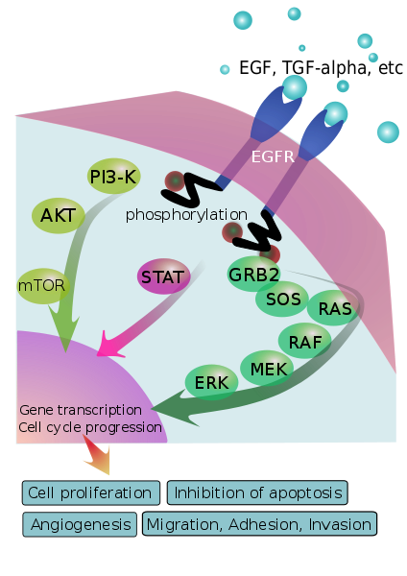**Tyrosine Kinases Receptors:**

* Growth factors.
* Cytokines in the immune system:
  + activation of B cells by TH –cells
  + activation of TC cells by TH –cells

**Mechanism:**

1. Binding of ligand induces dimerization of receptor, activating intrinsic kinase activity in the cytoplasmic domain.

2. Cytoplasmic domain of receptor becomes phosphorylated.

3. Phosphorylated receptor binds additional proteins that become activated by phosphorylation.

4. Typically there is a signal pathway, many proteins are activated by phosphorylation.

5. last activated proteins becomes localized to the nucleus were they affect transcription of many genes, leading to cell growth and proliferation.

**HER2+ Breast Cancer:**

* The HER2 gene codes for the epidermal growth factor receptor (EGF).
* Expression of the Her2 gene is increased in ~25% of early stage breast cancers. The cells bind more growth hormone and grow unchecked.
* A new anti-tumor drug used to treat this type of breast cancer is Trastuzumab, in combination with other standard chemotherapies.

*What is Trastuzumab?*