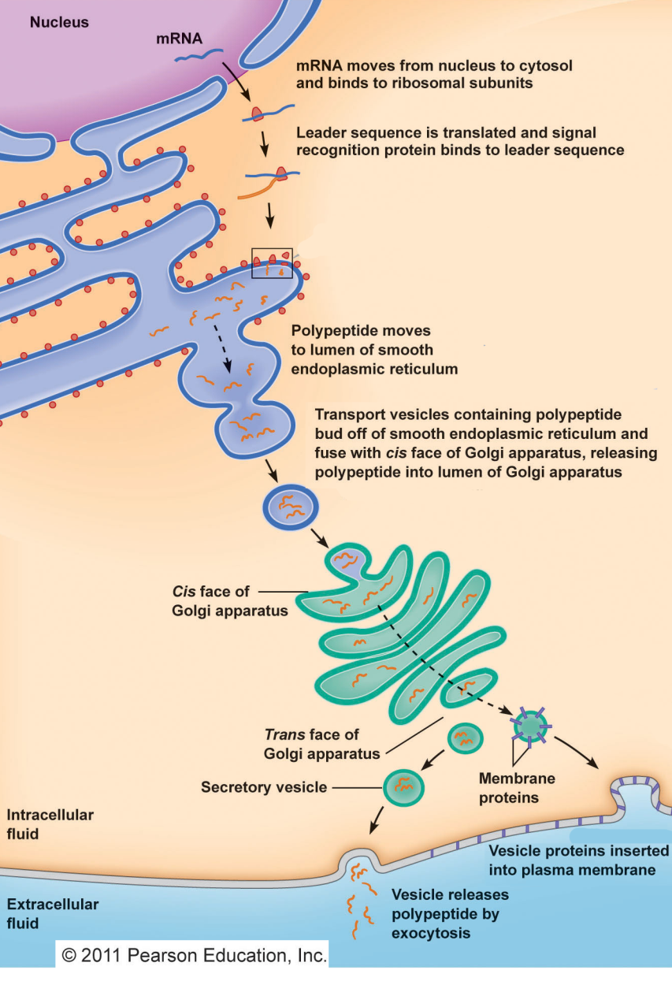**Lecture 26 – Protein Export, Hypocholesterol Disease.**

**Eukaryotic Secretory Pathway:** Proteins are targeted for export by the presence of an amino terminal “signal sequence” or “leader peptide (L)”. The signal sequence is ~20 amino acids long and consists of hydrophobic amino acids.

**Overview:**

* All mRNA is transported out of the nucleus after splicing/polyA addition.
* Protein synthesis begins on soluble ribosomes in the cytoplasm
* Ribosomes that are making proteins for export dock on rough endoplasmic reticulum (ER).
* Carbohydrate residues are added to the protein in the golgi.
* Vesicles bud off of the golgi and then fuse with the cell membrane.
* Vesicle contents are released outside of the cell.
* Membrane bound proteins in the vesicle become incorporated into the cell membrane.

**Details of Rough ER Events:**

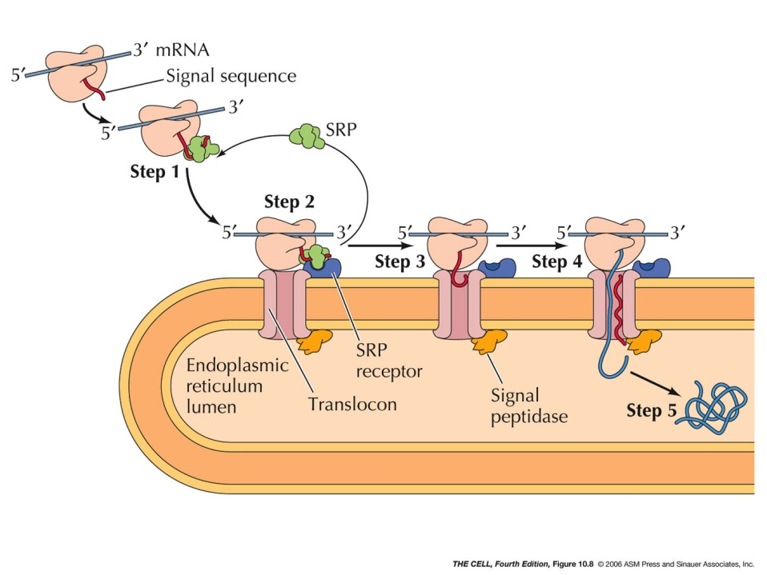1. When the signal peptide emerges from the exit tunnel of the ribosome, it binds to the **signal recognition particle** (SRP), which targets the ribosome to the membrane of the endoplasmic reticulum. The ribosome binds to the **rough ER** (the “rough” part are the ribosomes).

3. Protein translocation through the ER membrane continues, pushing the protein into the ER.

4. Signal peptidase (protease) cuts off the signal sequence.

5. Protein folds, continues on to golgi.

**Soluble versus membrane bound proteins:** Membrane bound proteins have a non-polar sequence at their c-terminal end, “anchoring” them in the membrane.

**Example**: Antibodies are either membrane bound (B-cells) or soluble (produced by plasma cells). The heavy chain gene has two important features:

* An amino terminal leader sequence that starts the export process.
* Alternative C-terminal sequences, coding for polar or non-polar amino acids.

**Production of Soluble or Membrane bound antibodies:**



The selection of the C-terminal sequence is due to alternative splicing of the heavy chain mRNA.

* Membrane bound: the “M” exon is retained, coding for non-polar residues that hold the antibody on the membrane.
* Soluble antibody; The “S” exon is used, coding for polar amino acids, so the heavy chain remains soluble.

Light chains are added in the ER, making the complete antibody (2L+2H):

**Cholesterol Metabolism & Familial hypercholesterolemia.**



* Main source of cholesterol is from synthesis in the liver. Levels are regulated by sensing overall cholesterol levels in blood.
* 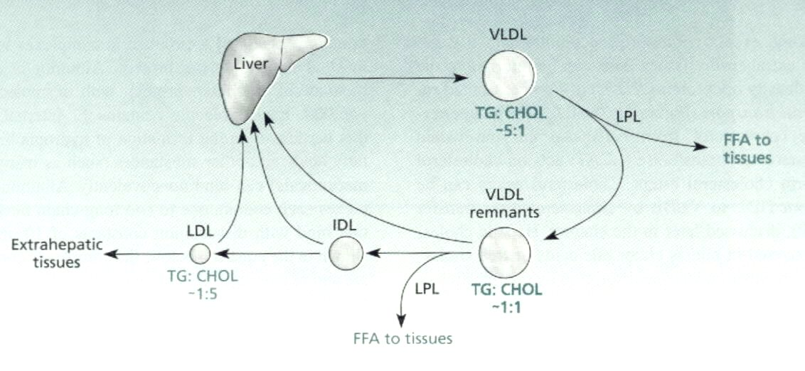Liver produces VLDL (very low density lipoprotein particles. Ratio of triglycerides:cholesterol 5:1.
* As these circulate triglycerides are removed, provided fatty acids to tissues. Eventually producing low density lipoprotein particles with a triglyceride:cholesterol ratio of 1:5.
* Re-uptake of cholesterol is by receptor mediated endocytosis of LDL particles
* Familial hypercholesterolemia – genetic disease where individuals lack the LDL receptor. Resulting in high cholesterol levels that cause coronary heart disease.

**Capture of LDL particles by Liver:**

* 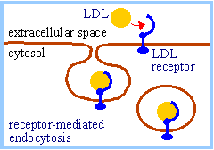LDL particles are captured by the liver by **receptor mediated endocytosis**, returning excess cholesterol to the liver.
* Endocytosis is the process by which cells internalize extra-cellular material. After endocytosis the material is in a membrane bound organelle called the **endosome.**
* Uptake of cholesterol reduces the synthesis of cholesterol, maintaining constant levels of cholesterol.

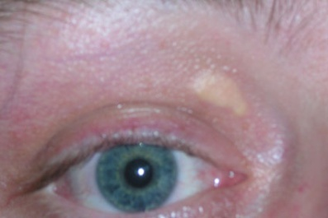**Familial Hypercholesterolemia.**

* Individuals have mutations in the LDL receptor that prevents the uptake of cholesterol.
* Disrupts regulation of cholesterol biosynthesis, liver produces more cholesterol than needed.
* Extra cholesterol forms deposits in the body, including in the interior of arteries, causing heart disease.

**Pathway for cholesterol biosynthesis:**

* 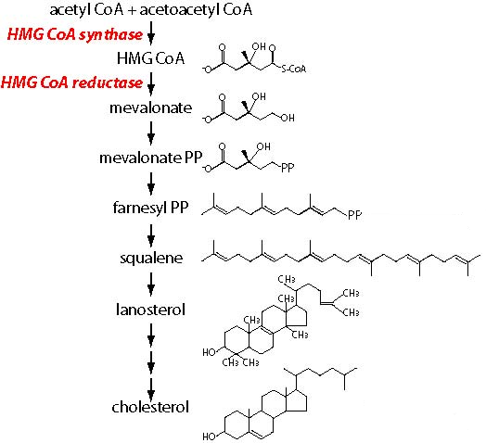Simple precursors, obtained from the metabolism of glucose, are converted to cholesterol by a multi-step pathway.
* Each step catalyzed by a different enzyme.
* Each step results in a relatively small change in the chemical structure.

**Statins:** Discovered in 1976, initial compound isolated from fungi. Modified to make the commercial drug lovastatin.

* Statins resemble HMG CoA, an intermediate in cholesterol biosynthesis.
* Statins inhibit the enzyme that uses HMGCoA as a substrate (HMG CoA reductase), preventing the synthesis of cholesterol.
* Reduce incidence of heart attack and stroke.

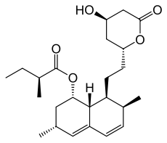Yearly revenue for statins:



_____________________?