**Lecture 21: Protein Synthesis – Translation of mRNA to Protein**



**Review:**

1. LacI gene (on chromosome) makes lac repressor
2. Lac repressor binds to lac operator on plasmid, no mRNA is made
3. IPTG binds to lac repressor, causing allosteric change, leaves DNA
4. RNAPol can now make mRNA, mRNA is used to make protein.

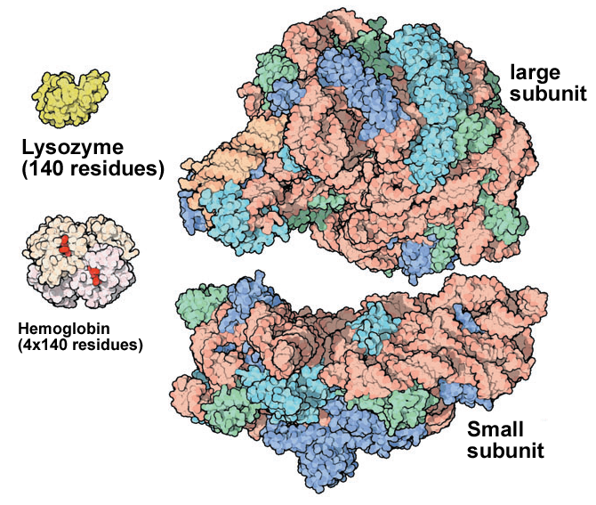**Expectations:**

1. Ribosome Structure – role of small and large subunit, overall structure, tRNA binding sites.

2. Control Elements on Plasmid (mRNA): Ribosome binding site, start codon, stop codon.

3. RNA molecules involved in protein synthesis. Role of each type of RNA.

4. tRNA charging. Addition of the correct amino acid to the correct tRNA.

6. Overall process of peptide chain elongation. Role of SD sequence, GTP, instead of ATP, provides energy required.

7. Effect of antibiotics on protein synthesis.

**RNA molecules involved in protein synthesis:**

a) **mRNA** – messenger RNA is copy of the DNA that encodes a gene. mRNA specifies the order of amino acids to be used in making the protein.

b) **tRNA** – transfer RNA is the dictionary the converts the codon to a specific amino acid. One part of the tRNA recognizes the codon, the other part contains the aminoacid to add.

c) **rRNA** – ribosomal RNA is found in the ribosome and is responsible for most of the function in protein synthesis.

**Protein Synthesis - Overview:**

1. 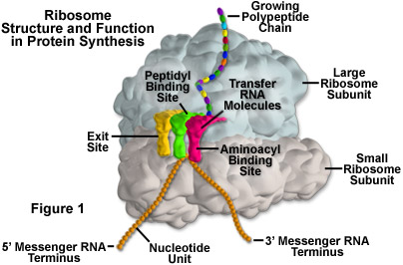The information content of the mRNA is *translated* into a polypeptide chain by the **ribosome**. The ribosome is a large complex structure contains both proteins and RNA (rRNA). It contains two subunits – one large and one small.
2. Has three tRNA binding sites, Amino acyl site (A), Peptidyl site (P), exit site (E).
3. mRNA binds to small subunit, at the 5’ end of the mRNA.
4. Polypeptide chain emerges from the top of the large subunit, through the exit tunnel.
5. Three nucleotide bases in the mRNA, or a **codon**, encode each amino acid.
6. Synthesis of the polypeptide chain proceeds in the **amino→carboxy** direction, as new amino acids are added to the carboxy terminus of the growing peptide chain.

*The ribosome is a mRNA (template) dependent protein polymerase – no primer required.*

**Control Sequences on the Plasmid** These function at the mRNA level, but need to be part of the plasmid DNA sequence so that they are copied to the mRNA sequence.



1. Ribosome binding site: Positions the mRNA on the ribosome
2. Start codon: AUG – sets reading frame, codes for 1st amino acid
3. Stop codon: Signals the end of the protein

**Features of the mRNA** (Example - Synthesis of Met-Lys-Ala).

**Beginning with the DNA:**

**TTGACA**TTTATGCTTCCGGCTCG**TATAAT**GTGTG**G**AAT**TGTGAGCGGATAACAATTTCACACA**GGAGGAACAGCT**ATGAAAGCTTAATTTATG.**

**AACTGT**AAATACGAAGGCCGAGC**ATATTA**CACAC**C**TTAACACTCGCCTATTGTTCCCGTGTGTCCTCCTTGTCGA**TACTTTCGAATTAAATAC**.

-35 -10 → Lac operator

Promoter mRNA start

**The mRNA:**

*Without punctuation – more than one possible start codon (AUG).*

**G**AAUUGUGAGCGGAUAACAAUUUCACACAGGAGGAACAGCU**AUG**AAAGCUUAAUUU**AUG.....**

**123456789012345678901234567890123456789012345678901234567890**

*With punctuation (correct reading frame defined by Ribosome binding site on mRNA).*

**G**AAUUGUGAGCGGAUAACAAUUUCACAC**AGGAGG**AACAGCU**AUG,AAA,GCU,UAA,UUU,AUG...**

**fMet-Lys-Ala-STOP**

|  |  |  |  |
| --- | --- | --- | --- |
| **Ribosome Binding Site (RBS)**: (Shine-Dalgarno [SD] sequence-AGGAGG.)  *Positions mRNA on the ribosome so that the correct start codon is used.* | **Start codon:** AUG codes for the 1st amino acid, always a modified methionine (N-formyl methionine, fMet) in prokaryotic cells.  *This codon sets the reading frame.*    N-formylMet Met | **Codons:** Each triplet of bases following the start codon codes for one amino acid.  *Translation performed by appropriately charged tRNAs.* | **Stop codon:**  Signals end of the protein (UAG, UAA, UGA)  Completed protein is released from ribosome |

**tRNA:**

* There are at least 20 tRNA molecules, one for each amino acid.
* Since there are fewer tRNAs than codons, some tRNAs recognize more than one codon.
* **Acceptor stem:** amino acids are attached to the 3' terminus of the tRNA by enzymes called **aminoacyl-tRNA Synthetases (aaRS).** These enzymes attach the *correct* amino acid to the *correct* tRNA. This process is often referred to as “charging” the tRNA.
  + There is one aaRS for each tRNA.
  + The amino acid is covalently linked to the 3’ end of the tRNA via an ester linkage.
  + Energy is required to add the amino acid to the tRNA. This energy is provided by ATP.
* **Anti-codon arm**: contains the anticodon triplet that translates the codon in mRNA to an amino acid. Watson-Crick H-bonds are used here.

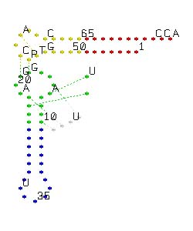

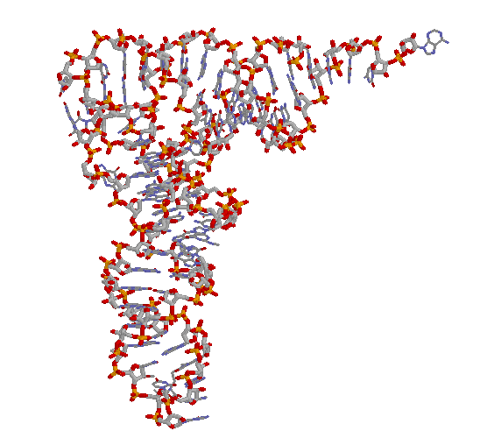

**Polypeptide Synthesis:**

1. The polypeptide grows stepwise as a ribosome-bound, peptidyl-tRNA. Discrete sites on both ribosomal subunits are involved in elongation.



a) The **A site** binds the **aminoacyl-tRNA** (charged tRNA) carrying the next amino acid. Formed by both the large (50s) and small (30s) subunits.

b) The **P site** holds the **peptidyl-tRNA** at the start of each cycle **-** the growing chain. Formed by both the large (50s) and small (30s) subunits.

c) The **E site** is the **exit** site for the uncharged tRNA that was previously in the P site after peptide bond formation.

During protein synthesis the path of one tRNA through the ribosome is: **A site → P site → E site**. By the time it gets to the E site it has added its amino acid to the growing polypeptide chain.

**Step I - Chain Initiation:**

i) mRNA first associates with the small ribosomal (30s) subunit – the ribosome binding site forms Watson-Crick hydrogen bonds to a region at the 3' end of the rRNA in the 30S subunit of the ribosome.

ii) fMet-tRNAfMet and the large subunit (50s) combine to form the initiation complex.



**Step II - Chain Elongation: (**Synthesis of Met-Lys-Ala; mRNA = SD-AUG-AAA-GCU-UAA) RBS = ribosome binding site)



a) fMet-tRNA occupies the P site in the first cycle. Growing protein is found here at the beginning of subsequent cycles.

b) aminoacyl-tRNA-Lys (next AA to be added) is brought to the A site.

c) Peptidyl transfer, or **transpeptidation** occurs - the free amino group of the amino acid in the A-site makes a peptide bond with the carbonyl group of the amino acid (or peptide) attached to the tRNA in the P-site.

d) Translocation (movement) of the ribosome occurs, shifting the ribosome relative to the tRNAs.

e) The uncharged tRNA leaves the E site, cycle is complete.



**Step III - Chain Termination:**

Protein release factor (which is a protein that looks like a tRNA) binds to the stop codon to finish the polypeptide chain. Water hydrolyzes the peptide from the P-site, releasing the complete tri-peptide. The mRNA is released and the ribosome 30s and 50s subunits dissociate.

