**Lecture 19: DNA transcription and Introduction to Gene Regulation**

**DNA Transcription (DNA→mRNA)**



**mRNA**: Provides codons for protein synthesis.

**tRNA**: Required to translate codons to amino acids.

**rRNA**: Found in the ribosome, the cellular organelle that synthesizes proteins.

**Promoter:** DNA sequence that RNA polymerase binds. -35 and -10 regions are binding sites for RNA polymerase – sequence specific recognition of this region.

**Template strand:** mRNA is a copy of the template strand.

**Transcriptional termination signal**: Causes RNA polymerase to stop and leave DNA template so that only the gene of interest is transcribed into mRNA.

-35 region -10 region Start of mRNA→

TTGACA -------17 bp--------TATAAT---6 bp--- A(or G)—mRNA---------

AACTGT------------------------ATATTA-------- ---T(or C)--template stand

**←** *Optimal E. coli promoter* **→**

**RNA polymerase**:

* Holoenzyme: σ + α2ββ’. This assembly of polypeptide chains is required to recognize the promoter and initiate production of mRNA.



* Sigma factor (σ) Binds to promoter (P) sequence in a base specific manner.
* Core enzyme: α2ββ’. Sigma subunit is lost after about 10 bases have been incorporated. Core enzyme is capable of synthesizing RNA.
* Uses DNA as a template
* Does not require an external primer (makes its own).
* 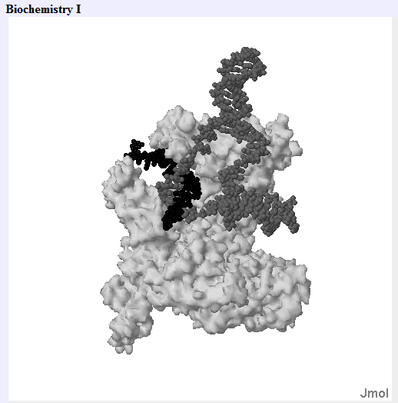Generates an RNA copy of the DNA template, so mRNA is the same sequence as the “top” strand of the DNA.
* NTPs are polymerized in the 5’→3’ direction.
* No error checking. This is OK since only a temporary copy of the DNA is being made.

**Inhibitors of prokaryotic RNA Polymerase :**

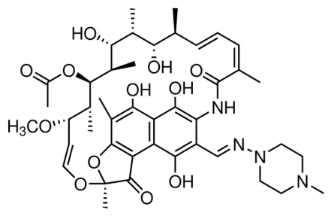 Rifampicin:

**Steps in the Synthesis of RNA.**



**1. Template binding**: Holoenzyme (R) binds to promoter sites (P), reversibly. Recognizing the -35 and -10 regions of the promoter using base specific hydrogen bonding. This is accomplished by the σ factor.

**2. "Open complex" formation**: An irreversible, committed step, DNA is melted (from bases -9 to +2 relative to the start of the mRNA). The exposes the template strand.

**3. Chain initiation:** When the RNA chain is about 10 nucleotides long, σ-subunit dissociates, leaving core enzyme to elongate the RNA **processively** (i.e. without dissociating from the DNA template).

**4. Chain elongation:** RNA chain growth is from 5' to 3', and elongation is rapid: about 50 nucleotides/sec.

**5. Chain termination:** Termination occurs at specific DNA sequences, causing release of mRNA.

**Example:** Write the sequence of the mRNA that would be generated from this DNA sequence.

CGCG**TTGACA**AATCGGTACGATCGATC**TATAAT**GCGCAT**A**GCGTAGCGTCG**..**

..GCGCAACTGTTTAGCCATGCTAGCTAGATATTACGCGTATCGCATCGCAGC..

-35 -10 S

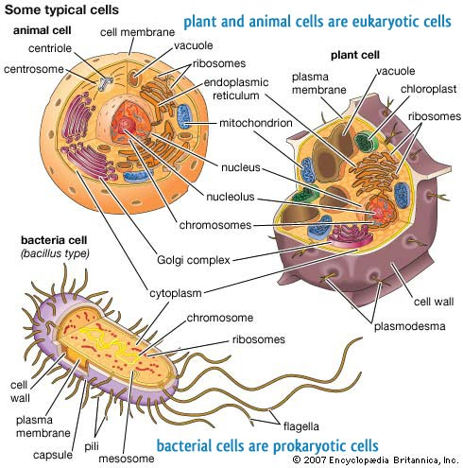**Control of Gene Expression:** All organisms control the expression of their genes so that they only make the appropriate proteins for the proper function of the cell. The control mechanisms are similar between bacteria (prokaryotic cells) and non-bacterial cells, such as mammalian cells (eukaryotes). Both types of cells have:

**Repressor proteins** – turn **off** gene expression. These recognize specific DNA sequences, binding to DNA using non-Watson-Crick hydrogen bonds. They can simply turn off gene expression by blocking the access of RNA polymerase to the DNA.



**Activator proteins** – turn **on** gene expression. They also bind to specific DNA sequences. They activate by recruiting additional proteins to the DNA (e.g. RNA polymerase) to increase the rate of mRNA synthesis.



There are a number of differences between regulation in prokaryotic cells and eukaryotic cells:

1. In eukaryotes the proteins that regulate gene expression are made by ribosomes in the cytosol and have to be imported into the nucleus.

2. In eukaryotes, each gene is regulated independently. In contrast, many bacterial genes are regulated at the same time as part of an operon (see below).

3. Many eukaryotic genes are regulated by DNA sequences very distant from the gene. These are referred to as enhancer sequences.



*Typical Eukaryotic Gene*

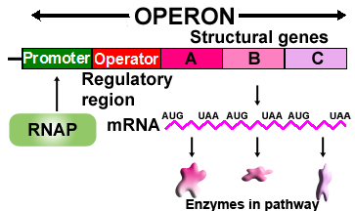4. In prokaryotic cells, genes that produce proteins that function in a pathway are usually produced from a single mRNA (polycistronic message). Consequently regulation of the mRNA production regulates all of the enzymes involved in that pathway. Diagram on the right shows the production of three enzymes that convert substrate A to final product D. The entire region of DNA is called an **operon**.

