**Lecture 18: Restriction Enzymes, Ligase, and Expression of Proteins**

**Restriction Endonuclease:** [*endo* - cut within, *nuclease* - cleave nucleic acid]. Used by bacteria as a defense mechanism to degrade invading viral DNA. Named after bacterial species the particular enzyme was isolated from.



1. Enzyme binds to specific **recognition sequence**s in the DNA.

2. Enzymes use base specific interactions, recognizing non-Watson-Crick hydrogen bonds with the bases.

3. Recognize the same sequence on the top and bottom strand (referred to as palindromic sequences).

4. Cleave both strands at the same position.

**Enzyme Recognition Products**

**Sequence (substrate)**

**EcoRI(G^AATTC): -G-A-A-T-T-C -G A-A-T-T-C- 5’ overhang = sticky end**

**-C-T-T-A-A-G -C-T-T-A-A G-**

**PvuI(CGAT^CG): -C-G-A-T-C-G- -C-G-A-T C-G- 3’ overhang = Sticky end**

**-G-C-T-A-G-C- -G-C T-A-G-C-**

**EcoRV(GAT^ATC): -G-A-T-A-T-C- -G-A-T A-T-C- blunt end**

**-C-T-A-T-A-G- -C-T-A T-A-G-**

**HaeIII (GG^CC): -G-G-C-C -G-G C-C- blunt end**

**-C-C-G-G -C-C G-G-**

There are 100’s of restriction enzymes, some examples are:

|  |  |
| --- | --- |
| Eco R1: Example of specific hydrogen bonds with donor and acceptors at the edge of bases in the large groove (major) of dsDNA: | |
|  |  |

**DNA Ligase** – Uses the energy contained in a compound called ATP to join 5’phosphate to 3’-OH, provided the two groups are in close proximity. Fragments created by the same restriction enzyme can always be joined to each other.



Sticky end ligation:

-G A-A-T-T-C- -G A-A-T-T-C- --G**-**A-A-T-T-C--

-C-T-T-A-A G- -C-T-T-A-A G- --C-T-T-A-A**-**G—

Blunt end Ligations can also be accomplished, but with lower efficiency since the two molecules are not held together by hydrogen bonds. For example:

--G-A T-G-- --G-A T-G-- --G-A-T-G--

--C-T A-C-- --C-T A-G-- --C-T-A-C--

**Production of Recombinant Proteins in Bacteria.**

**Applications:**

* Production of proteins as drugs (e.g. Antibodies, human growth hormone).
* Production of proteins for drug development purposes (e.g. HIV protease).

**Overall Goal**: To produce HIV protease from a drug resistant HIV virus. The protein will be made in E. coli (a widely used bacteria) using recombinant DNA methods. The structure of the purified protein can be determined and new HIV protease inhibitors can be designed that will be effective against the altered virus. The overall procedure is as follows:



1) Isolate the genetic material (RNA) from the HIV virus. Viruses could be obtained from a patient’s blood, and small amounts (pg) of vRNA could be obtained.

2) Convert this material to DNA using polymerases (.e.g. reverse transcriptase).

3) Amplifying the protease coding region (gene) using PCR, adding restriction sites.

4) Insert the DNA encoding HIV protease into a bacterial expression vector (a specialized form of circular DNA) using restriction endonucleases and DNA ligase. *Verify sequence using DNA sequencing.*

**Properties of the expression vector:**

a) Provide antibiotic resistance to the host bacteria, such that only bacteria with the plasmid will grow in the presence of the antibiotic (selective pressure for maintaining the plasmid)

b) An origin of DNA replication so that the plasmid will be replicated with the bacterial DNA

c) DNA sequences that cause the production of mRNA, copying the information in the DNA to mRNA, including a regulated on/off switch (lac operator).

d) Sequences in the mRNA that start and stop the production of the recombinant protein.

e) Coding region for HIV protease+stop codon (f)

5) Transformation of the bacteria with the plasmid.

6) Growth of the transformed bacteria.

7) Production & purification of the recombinant protein.

8) Determination of structure by X-ray diffraction.

9) Drug design and other functional studies.

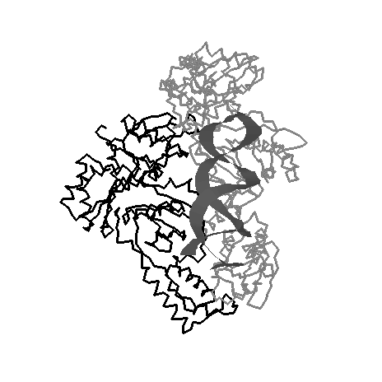**Steps 1-2:** From vRNA to a dsDNA copy using reverse transcriptase.

**Reverse transcriptase** has the following activities:

i. RNA dependent DNA polymerase activity.

ii. RNase activity, degrades RNA template.

iii. DNA dependent DNA polymerase activity.



**Step 3 – Amplification of HIV protease coding region & Incorporation of restriction sites.**

We would design primers to accomplish the following with PCR

* Addition of an EcoR1 site (GAATTC) to the 5’ end of the HIV protease gene.
* Addition of a Bam HI site (GGATCC) to the 3’ end of the HIV protease gene.
* Inclusion of all codons that code for the amino acids in HIV protease.

Left Primer: 5’-**GAATTC**cctcagat

Right Primer: 5’-**GGATCC**GAAATTTA

5'**GAATTC**

cctcagat3’

5'--------ttccctcagatcactctttggcaa-------TACtttaaatttccccattagtcctatt-----3'[U]

**ProGlnIleThrLeuTrpGln-----------LeuAsnPhe**

3'--------aagggagtctagtgagaaaccgtt-------ATGaaatttaaaggggtaatcaggataa-----5'[L]

**3’**atttaaag

**CCTAGG**5'

**The final product, after PCR.**

5' **GAATTC**cctcagatcactctttggcaa.......TTTAAATTTC**GGATCC** 3'

3' **CTTAAG**ggagtctagtgagaaaccgtt.......aaatttaaag**CCATGG** 5'

**EcoR1 ProGlnIleThrLeuTrpGln--------LeuAsnPhe BamH1**

**Step 4 - Insertion of the HIV coding sequence (PCR product) into the Expression vector.**

