**Lecture 9 - Antibody Structure & Protein-small Molecule Binding.**



**Disulfide bonds:** These are covalent bonds between cysteine residues, they crosslink the otherwise linear polypeptide chains. They increase the stability of proteins and are often found on proteins that function outside of cells, such as antibodies.

**Antibody (Ab, Ig) Structure:**

**Quaternary structure:**

* 2 Light + 2 heavy protein chains.
* Light chains are identical on any given Ab (~200 AA)
* Heavy chains are identical on any given Ab (~400 AA)
* Two binding sites/molecule
* 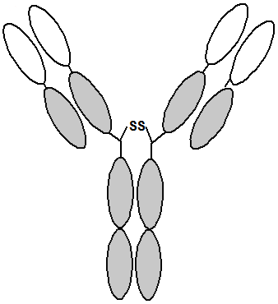Chains held together by disulfide bonds (and non-covalent forces).

**Primary Structure (Amino acid Sequence)**

* The sequence of both chains can be divided into a variable and a constant region
* The sequence of the constant region is the same on all light chains and all heavy chains (but the constant sequences are different on light versus heavy)
* The variable sequence is different between antibodies that bind different things.
* There are about 109 different L+H variable sequences at any given time, generated by a fascinating random process.
* Each H &L variable sequence binds to a different antigen.
* The H & L variable sequences form the **FV fragment.**



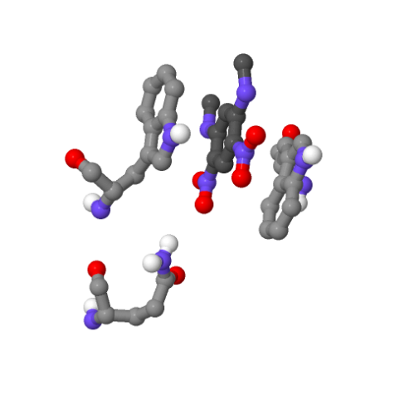**Antibody-Antigen Interactions.**

* A specific complex forms between the antigen and the antibody.
* This complex is stabilized by complementary interactions between the antigen and amino acid residues from the antibody. One, or more, of the following interactions can stabilize the complex:

i) Hydrophobic effect – non-polar regions on antigens

ii) Hydrogen bonds – polar antigens with donors or acceptors.

iii) Van der Waals – shape complementarity

iv) Electrostatics – opposite charges attract!



Example, the complex between dinitrophenyl and an antibody:

**Applications of Antibodies:**

**A) Drug detoxification** – antibodies bind drugs, preventing them from being toxic.

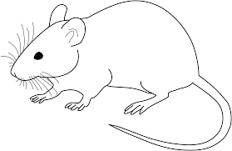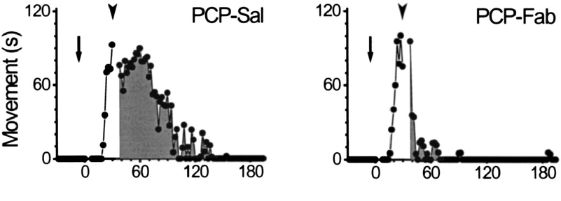

**B) Treatment of Cancer**

|  |  |  |
| --- | --- | --- |
| **Trade Name** | **Used to Treat:** | **Approved in:** |
| Rituxan | Non-Hodgkin lymphoma | 1997 |
| Herceptin | Breast cancer | 1998 |
| Mylotarg* | Acute myelogenous leukemia (AML) | 2000 |
| Zevalin* | Non-Hodgkin lymphoma | 2002 |
| Bexxar* | Non-Hodgkin lymphoma | 2003 |
| Erbitux | Colorectal, Head & neck cancers | 2004, 2006 |
| Avastin | Colorectal cancer | 2004 |

Cancer cells eliminated by:

i) Antibody carries drug to target cell.

ii) Antibody on surface causes the immune system to destroy the target cell.