Lecture 8 - Introduction to Immunology
Normal functions of the immune system:

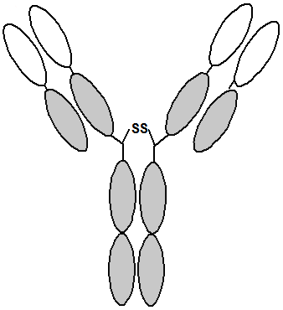
A mis-function of the immune system:

Some definitions:
Antigen = something that is recognized by the immune system.
Antibody (Ab, Ig) = Y-shaped protein that recognizes antigens, found on the surface of B-cells or secreted by plasma cells.
B-cell = involved in antibody production, has antibody molecule on its surface. Develops into plasma cells after activation by T_{H} cells.
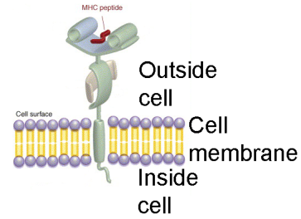
Plasma cell = derived from B-cell after activation of the B-cell, produces secreted antibodies.
T_{C} cell = part of the cellular immune system
T_{H} cell = Activate both B and T_{C} cells.
MHC = major histocompatibility complex – protein found on the surface of all cells. MHC presents antigens to T cells, leading to activation of B and T_{c} cells.
- B-cell: antigens originate from binding to Ab on surface of cell.
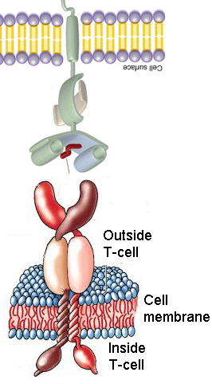
- All other cells: antigens are from cellular protein synthesis – viral proteins made in infected cells or abnormal proteins in cancer cell.
TCR = T-cell receptor – found on the surface of T-cells, recognizes MHC proteins.
Two branches of the immune system:
A. Cellular:

a) Cell presents virus/cancer antigens on their MHC to T cells.
b) T_{H} cell activates T_{C} cells, allowing the T_{c} to kill virally infected cells.

B. Humoral (body fluids) = antibodies
a) B-cell binds antigen (e.g. bacteria) on the antibody on its surface.
b) Antigen is brought into the cell (internalized)
c) Antigen is broken down
d) A small protein fragment of the antigen is displayed (presented) on the MHC on the B-cell
e) B-cell is recognized by T_{H}-cell due to MHC-TCR interaction.
f) B-cell develops into plasma cell
g) Plasma cell secretes antibody that binds to antigen, leading to its destruction.

