# Lecture 7: Secondary and Tertiary Structure.



**Secondary Structure**:

* Two prevalent structures – α-helix, β-sheet.
* Stabilized by mainchain hydrogen bond

α-helix – within the sequence

β-sheet – between strands.

* C=O hydrogen bond acceptor
* 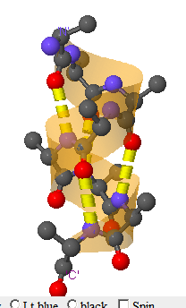N-H hydrogen bond donor

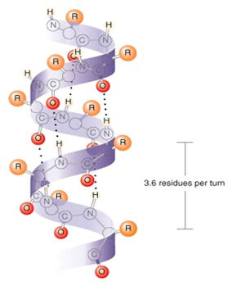**α-Helix Structures**

Dimensions, geometry, & H-bonds

3.6 residues/turn

5.4 Å/turn

H-bonds || to helix axis.

Sidechains point outwards

Right handed twist.

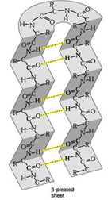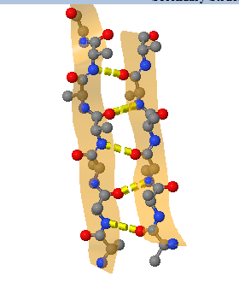**Beta Structures -** β-Sheets

H-bonds perpendicular to direction of strands.

Sidechains point up and down, **above** and **below** the sheet.

a. parallel

b. antiparallel

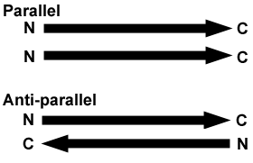

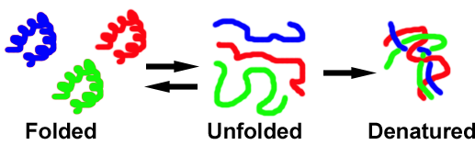**Tertiary Structure:**

Folded proteins have a well-defined, unique tertiary structure. *The folded form of a protein is the active form.*

The tertiary structure is often formed by the assembly of secondary structures. Remember that the tertiary structure refers to the conformation of all of the atoms in the chain, both mainchain and sidechain.

i) compact, well packed.

ii) contain H-bonded secondary structures

iii) have the following distribution of amino acids:

|  |  |  |
| --- | --- | --- |
| **Amino Acid type** | **Inside** | **Outside** |
| Polar |  |  |
| Charged |  |  |
| Non-polar |  |  |

**Flexibility of Proteins:**

**Peptide bond:**



1. It cannot rotate (partial double bond).
2. The carbon is planer because it is bound to three atoms.
3. The nitrogen is also planer, so all four atoms (O, C, N, H) lie in a plane.
4. The C=O can accept a hydrogen bond
5. The N-H can donate a hydrogen bond, but cannot accept one since it is involved in a partial double bond.
6. Trans form (left drawing) is more stable than cis (right drawing).

**N-Cα & Cα-CO –** are single bonds and are freely rotatable, giving the unfolded polypeptide chain considerable flexibility.

* The large number of possible conformations **greatly** stabilizes the unfolded state of proteins because disorder is favored (disorder is also referred to as entropy).



***The unfolded form of proteins is stabilized by the large increase in disorder (entropy) when the protein unfolds.***

**Then why do proteins fold?** To understand protein folding, we need to understand how the different amino acid side chain groups can interact with water, and then with themselves.

**The “forces” that stabilize the folded tertiary form of the protein are:**

1. **Hydrophobic effect**:



* Water molecules coat exposed non-polar residues in the unfolded state with a hydrogen bonded shell of water molecules.
* The water is immobilized and its **disorder (entropy) is decreased**, this is unfavorable.
* If the non-polar group is removed from the water during folding of the protein, the water’s disorder (entropy) is increased because it no longer has to form the shell around the non-polar sidechain.
* Therefore, non-polar residues are forced out of the water into the core of the protein – “oil and water don’t mix”

***The change in the entropy of the water when non-polar groups are placed in water is called the hydrophobic effect.***

***The hydrophobic effect stabilizes the folded state of the protein because non-polar groups are buried in the core.***

**2. van der Waals** – the core of folded proteins are tightly packed – optimizing van der Waals. Knobs fit into holes quite nicely. van der Waals are also known as induced dipole-induced dipole, induced dipole-dipole, dipole-dipole)



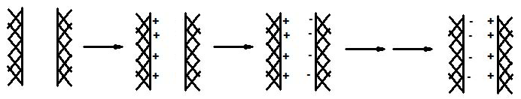

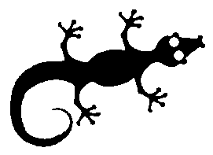These arise due to the temporary appearance of charges on the surface of all matter due to very fast fluctuations in the electrons near the surface. A charge on one surface will appear and induce the opposite charge to appear on the other surface, creating a favorable electrostatic interaction. This then reverses, as shown above. This interaction generates a favorable energy in all cases, until the surfaces get too close together and the electrons on one atom are forced into the electrons of another, leading to a very strong respulsive force. The distance from the nucleus that gives the lowest energy is called the **van der Waals radius** of an atom.

Van der Waals forces allow the Gecko to walk on ceilings!

***The van der Waals forces in the well-packed core of the folded protein stabilize the folded form of proteins.***

**3. H-Bonds:**



* Found in secondary structures

***The hydrogen bonds also stabilize the folded form of the protein***.



**1+2+3:** The favorable hydrophobic effect, van der Waals and H-bonds all combine to make the folded protein of the protein more stable than the unfolded form, at least at low temperatures.

What happens when the temperature is raised? What happens when you cook an egg?

**Sequence, Structure, and Function**

* The order of the amino acids determines the final folded state of the protein.
* Proteins of different sequence will fold into different shapes, with different functions.
* The dominate interaction that affects the final folded structure is the burial of non-polar (hydrophobic) residues in the core of the protein.
* Consider the following 12 residue protein, where the first four residues are non-polar (filled circles).



**Diseases Related to Protein Folding:**

**A. Multiple folded forms.**

* Proteins usually fold into a single stable conformation.
* Some proteins can assume two or more folds.
* Misfolded proteins can sometimes cause disease because they can be prone to aggregation.



**Prions** – infectious agents that are composed of only protein.

* Mad-cow disease
* Cruetzfeld-Jakob Disease

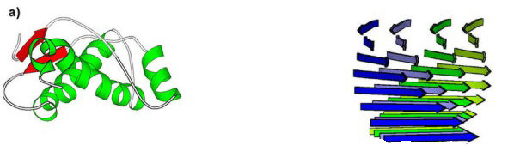

**B. Proteins with altered sequences (mutations in the genetic material)**

* Changes in the order of the DNA bases in the DNA (mutation) can lead to a change in the amino sequence in a protein.
* For surface residues, these changes often (but not always) have little effect on folding. They may have large effects on function.
* For buried residues, replacement of one non-polar amino acid by another can distort van der Waals interactions, making the mutant protein less stable, easier to unfold.

**Review:**

1. Can you compare and contrast the main features of primary, secondary, tertiary and quaternary structure.

2. You should know the properties of the peptide bond:

* Planer
* No rotation, due to partial double bond.
* Trans form most stable.

3. Can you explain why peptides/proteins can be very flexible when unfolded and that the high disorder in the unfolded state will stabilize the unfolded stated.

4. Can you relate the structure of a folded protein to the forces that stabilize it?

* Hydrophobic effect → non-polar core
* Van der Waals → well packed core
* Hydrogen bonds → plenty of secondary structures

5. The sequence of amino acids affects the structure and the function.

6. Protein folding diseases are due to:

* Multiple folded forms & aggregation
* Mutations, leading to amino acid changes that affect folding (and function).