**Lecture 4: Polar Bonds, Functional Groups, Water Structure, H-bonds and pH.**

**Polar (and non-polar) bonds:**

**Electronegativity**: The ability of an atom to attract electrons.



The degree of sharing of electrons by atoms depends on the difference in their electronegativity. The atom with the higher electronegativity will pull electrons from the atom with the lower electronegativity. One atom will develop a **partial positive charge and the more electronegative atom will develop a partial negative charge.** Bonds with large differences in partial charges are called polar bonds.

|  |  |  |  |  |  |  |  |
| --- | --- | --- | --- | --- | --- | --- | --- |
| 1  **H**  2.1 |  |  |  |  |  |  | 2  **He** |
| 3  **Li**  1.0 | 4  **Be**  1.5 | 5  **B**  2.0 | 6  **C**  2.5 | 7  **N**  3.0 | 8  **O**  3.5 | 9  **F**  4.0 | 10  **Ne** |

*Electronegativity increases across the periodic table →*

**Aromatic Compounds**

* Atoms connected in a ring formation, can contain nitrogen.
* Form single bonds + ½ double bond with each other.
* Ring is planer – cannot be chiral because none of the carbons are bound to four different atoms.



**Organic molecules and Functional Groups:**

Functional groups are subsets of atoms within a larger molecule, e.g. methyl group, ethyl group. Functional groups have unique properties, e.g. methyl and ethyl are non-polar, alcohols polar, etc.

**Reminder of** “short hand” notation:

* Carbons are located at the end of lines and at kinks in the line.
* Hydrogens are not drawn, you need to add sufficient hydrogens to satisfy the number of bonds of the other atoms, e.g. 4 for carbon.



**Non-Polar (hydrophobic) Functional Groups**

**Polar (hydrophilic) Functional groups:**



**Example: Identifying functional groups:**

a) What functional groups are common to all four of these amino acids?

b) What functional groups are different between each amino acid?



**Structure of Water – H2O**

1. Oxygen has the following electronic configuration: *1s22s22p4* – a total of 8 electrons.

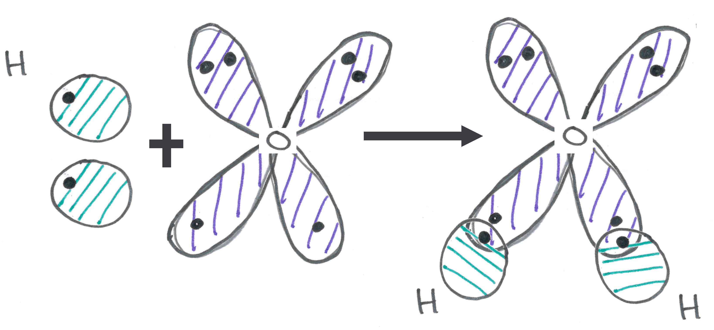

1. The 1st shell is full, and the second shell has 6 electrons.
2. Oxygen forms _________ bonds.
3. Oxygen, like carbon, will have a tetrahedral shape. However, in this case two corners of the tetrahedron are the two atoms that oxygen is bound to and the other two corners of the tetrahedron are occupied by the two full orbitals of oxygen.
4. The tetrahedral shape is the lowest energy, maximizing the distances between the hydrogens as well as the full orbitals.
5. Consequently, water is a bent molecule.



1. The large electronegativity difference between hydrogen and oxygen make the O-H bond polar, and water is a polar molecule because of the two polar bonds.
2. The polar bonds in water interact to form **Hydrogen bonds.**

**Hydrogen Bonds**

i) Formation of H-bonds is primarily an electrostatic attraction between:

* Electropositive hydrogen, attached to an electronegative atom is the hydrogen bond **donor** (*i.e.* NH)
* Electronegative hydrogen bond **acceptor** (*e.g.* the lone pairs of oxygen in the case of water, or C=O group of an amide).

ii) Typical length: 1.7 Å between electronegative atom and the hydrogen. (compare to covalent bonds ~ 1 Å)

iii) Typical angle for the three atoms: 180° ± 20°

iv) Typical energy: 20 kJ/mole (compare to covalent bonds 200-400 kJ/mol). Therefore these bonds are easy to break, **allowing reversible binding**.



**Example**: Identify the hydrogen bond donor and acceptor in the following diagram:

**Biochemical Significance of Hydrogen Bonds in Water:**

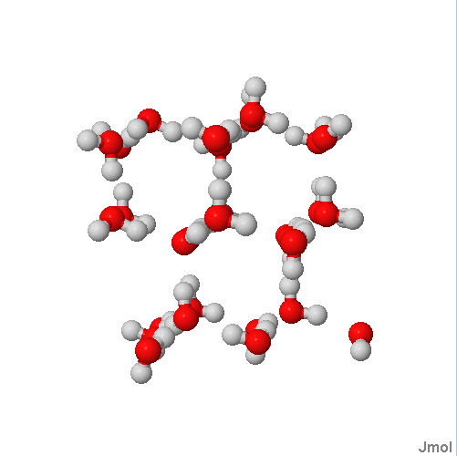

i). In ice, the hydrogen bonds cause the formation of cavities in the ice, lowering the density of the solid, thus ice floats instead of sinks, allowing it to melt during the summer on lakes. For most other solids, their density is higher than the liquid form.

ii) In liquid water, the hydrogen bonds persist, and are transient, generating small short-lived (nsec) clusters of "ice" in liquid water. These hydrogen bonds are present over a wide temperature range. This gives water a high heat capacity – the ability to absorb energy (heat) without a large increase in temperature.

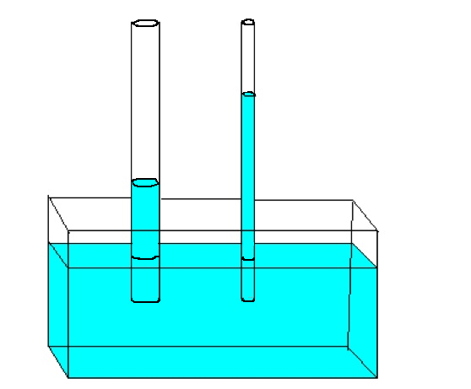

iii) The hydrogen bonds of water give it a strong surface tension or force, allowing water to climb up narrow tubes (capillary action). This is used by plants to transport water from the roots to the leaves. The water forms hydrogen bonds with itself and donor/acceptors on the walls of the tube.



**pH – Acidity and Ionization.**

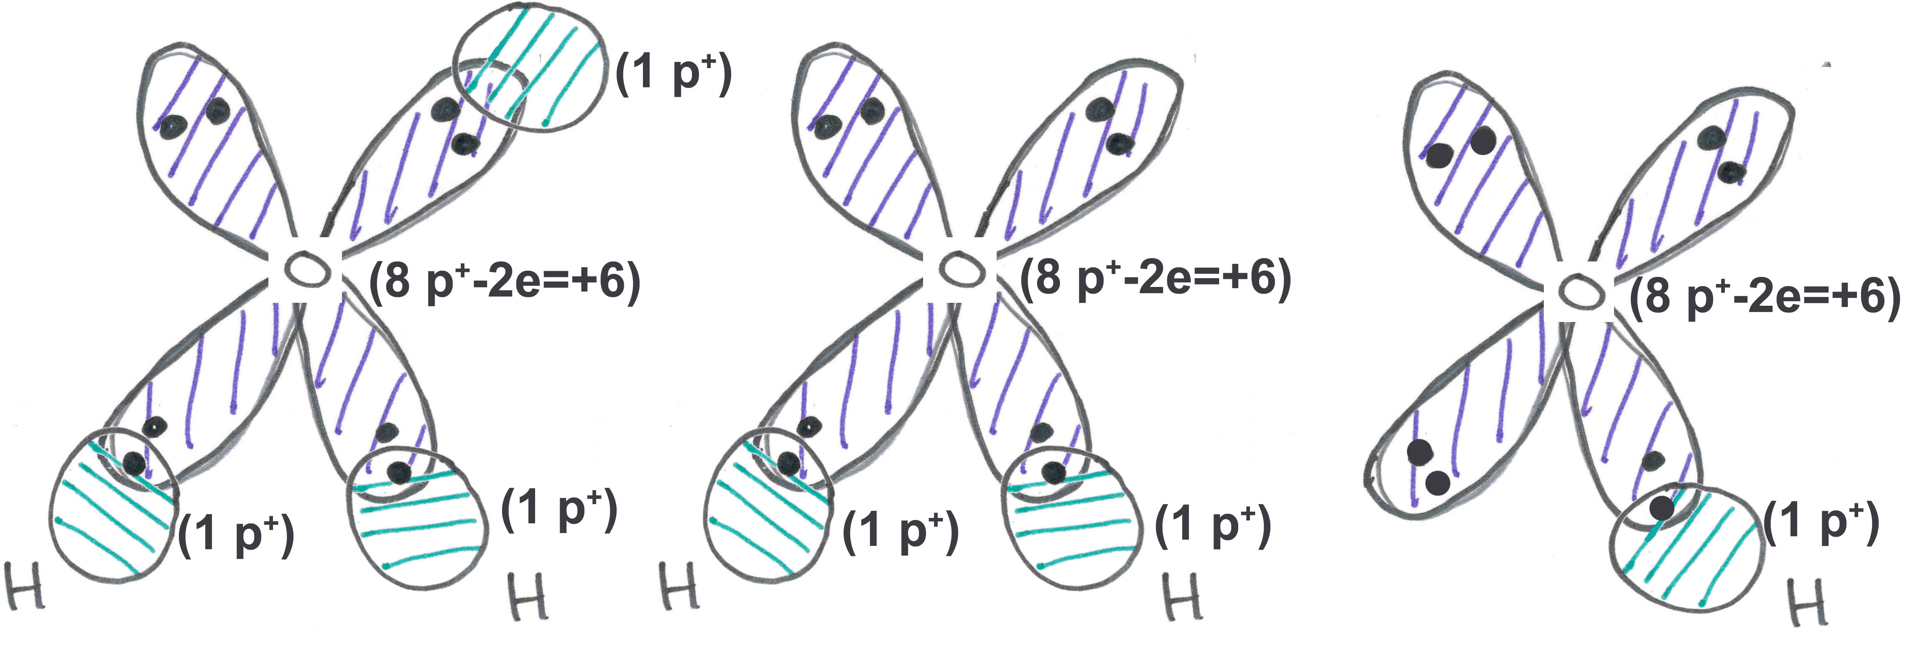

**Pure water contains three chemical species:**

* Water can gain a hydrogen ion (H+) to become a **hydronium ion**. In this case oxygen is forming three bonds! The added proton (H+) interacts with the full orbital of oxygen.



* The hydronium ion is often simplified as a bare proton – H+.
* Water can lose a hydrogen ion to become a negatively charged **hydroxide** **ion**, the exiting hydrogen left its electron to complete the 2nd shell of oxygen.

**pH:**

* pH is measured as the -log[H+], smaller pH, more acidic the solution.

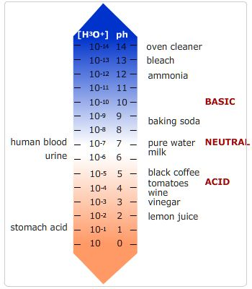

* Neutral pH is 7.0. At this pH there are an equal number of H+ and OH- ions in solution. [H+]=10-7 M.
* Solutions with pH values above 7 are referred to as alkaline or basic solutions.

**Why pH is important:**

When a functional group ionizes, its charge changes by an entire unit, either creating a charge or removing a charge. This can affect:

i) Ability of the drug to go through cell membranes. Membranes have a non-polar core and charged molecules cannot cross a membrane.

ii) Binding of the drug to its target. Charges on are drug will be matched by an opposite charge on its target (usually a protein), resulting in strong binding due to an electrostatic interaction (opposites attract).



**Review:**

1. Can you identify polar/non-polar bonds and molecules?



1. What are the properties of aromatic groups?
2. Structure of functional groups and their properties.
3. Identify H-bond donors and acceptors?
4. Importance of hydrogen bonding in the structure of ice and heat capacity. What is capillary action, how does it work?
5. pH scale, high concentration of hydronium ions = low pH
6. How can pH affect the movement of drugs across the membrane and binding to their targets?