Web Based Information Seeking

Scenario: Jacob is writing a paper on the design of hybrid cars. Using a library database, he was able to do a thorough literature review related to research on the engineering issues related to different types of hybrid cars. However, Jacob would like to situate his paper in more of a social context and give a flavor for how hybrid cars are viewed by the general public, and what the trade-offs are from a consumer standpoint. He wonders whether the web would be a good resource for him, and if so, what he could find that would enrich his research paper.

- What is the web useful for?
- More than just archival publications
- News
- Popular opinion
- Community resources (Wikipedia, Research centers and Consortia, code repositories)
- Activity: Could provide a “Have you ever used the web for…” list where we list various types of information that can be found on the web, with example links related to the scenario. It would serve to get the student to reflect on the extent to which he/she has experience with all that the web has to offer and to show examples of what could be found.

Scenario Continued: Jacob decides to use the web to find information about public opinion related to hybrid cars. However, he’s not sure where to start because the skills he learned for using the structured interfaces provided with library databases don’t seem to apply to the web based interfaces he sees on Google and Yahoo.

- How is the web different from library databases
- Content
- Not necessarily peer reviewed
- May be more up-to-date, but pay attention to copyright dates and author qualifications
- Forward reference to evaluation of sources segment
- Organization
- Indexed by content rather than metadata
- Hubs and authorities
- Term frequency –inverse document frequency
- Page rank
- Access
- Simpler search interface
- Most of what is available is free (but you get what you pay for…)

Scenario Continued: Jacob begins his search by typing “hybrid cars” into Google. He finds lots of consumer information, like product reviews, for various types of hybrid cars, but what he doesn’t find is popular opinion on why buy a hybrid car or not. He begins to slog through the seemingly endless list of returned links, but quickly becomes discouraged.

- What if my initial search for information is unsuccessful?

- Problem 1: Lots of irrelevant information

- Query terms may be ambiguous
- Query terms may be too general

- Problem 2: Little or no information

- Query terms may be too specific
- Query terms may be mismatched with popular use

Scenario Continued: Excited by his newfound search skills, Jacob tells his friend Ann about how he found information for his paper. However, Ann is not impressed because she managed to find similar information much faster by starting with some community resources she knew about.

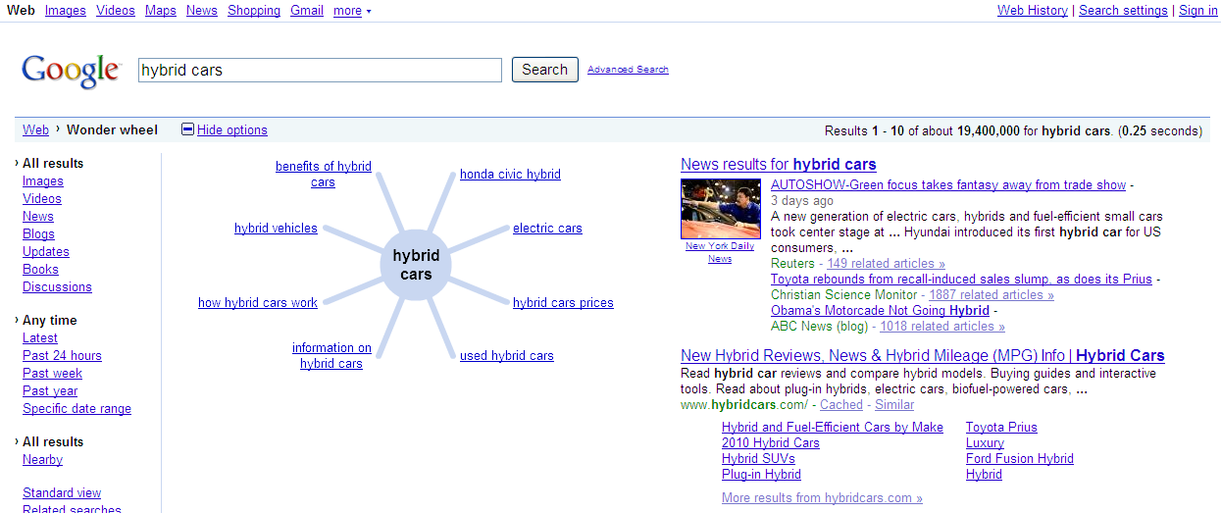

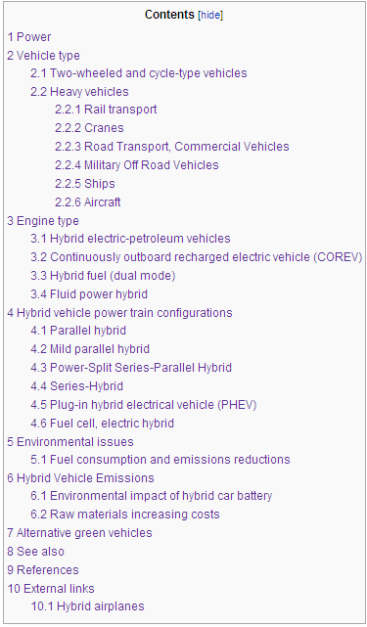

- What are useful strategies for web search?
- Google Scholar
- Google Wonder Wheel
- Wikipedia as a “launch site”

