Creating a new Servlet Application with TomEE and Java Enterprise

To prevent having to go through all configuration steps for TomEE every time a new IntelliJ project is created, we can simply create a Java Enterprise application that will do most of the work for us.
!!! In order to use Java Enterprise IntelliJ Ultimate Edition is required. !!!

- Open IntelliJ Ultimate
- Open the New Project dialog by clicking File -> New -> Project
- Select Java Enterprise
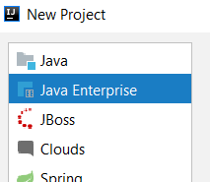

- In the “Additional Libraries and Frameworks” section scroll down and select “Web Application”.
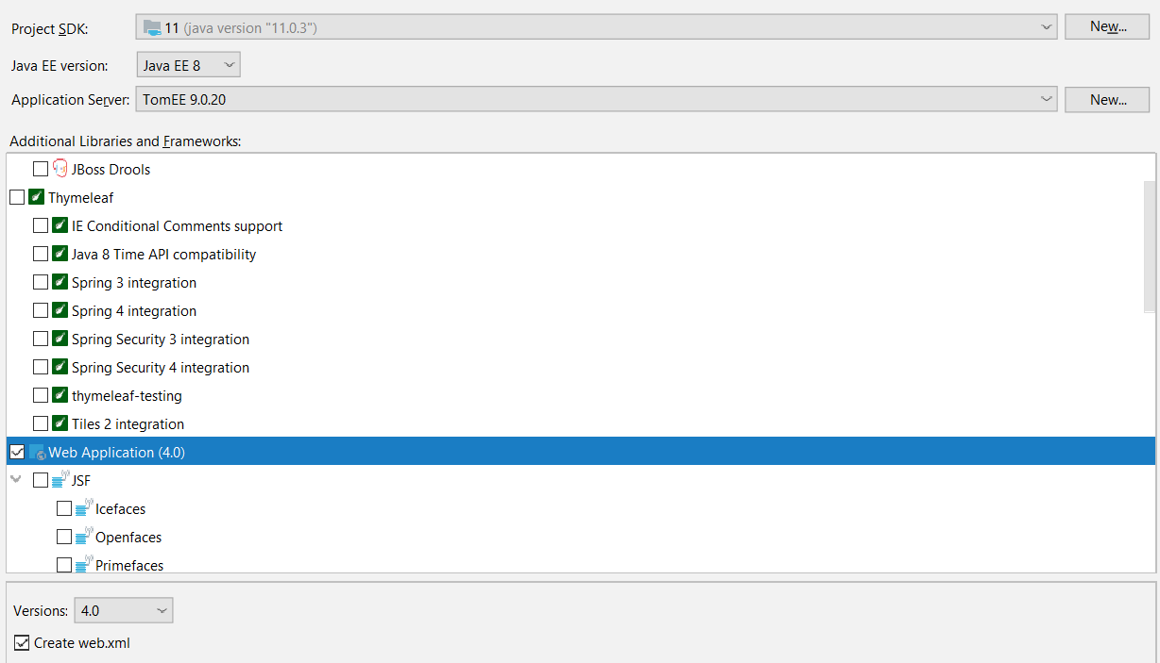

- The Project SDK is the Java SDK to use for this project. The Java EE version is the Java Enterprise version for this project. Unless specific versions are requested you can leave these as they are.
- If you don’t see an “Application Server”, click on the “New” button next to it on the right.

- Select TomEE Server.

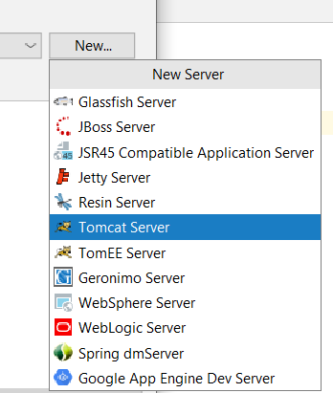
- You should see the following screen
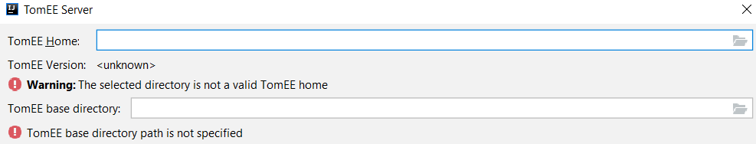

- Click on the folder icon on the right side of the “TomEE Home” field.
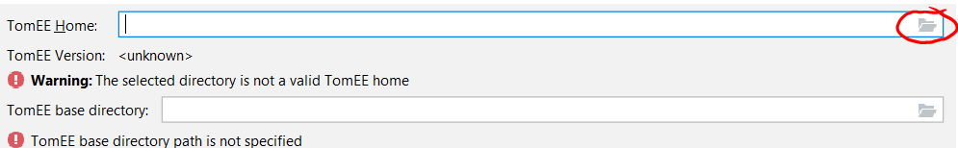
- Find and select the home directory of TomEE. This should be the downloaded and extracted folder where TomEE files are saved. (Note that this is not the “lib” folder of TomEE, but the actual top-level folder.)
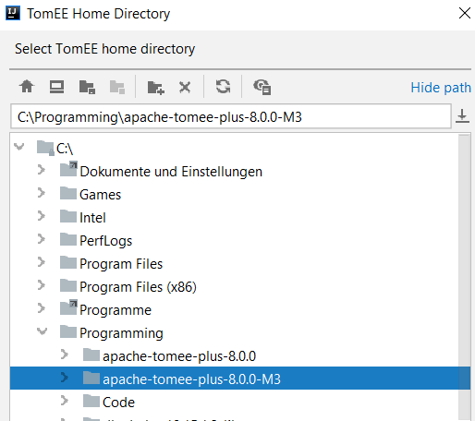

- IntelliJ should show you something along the following
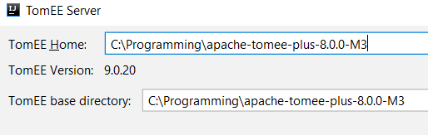
Note that your version can be different.
- Click on the “OK” button on the bottom left. IntelliJ should not start importing all necessary settings and information.
- Once completed you should see the “New Project” screen again. Under “Application Server” you should now see an entry for TomEE.
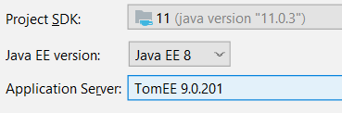
- Now click on the “Next” button at the bottom right of the window.
- Enter a project name and provide a location to save it.
- Click “Finish”.
- IntelliJ now opens with a standard project structure.
- TomEE settings can now be adjusted as normal in the top right corner.

