Table 1 Soil parameters of layered system
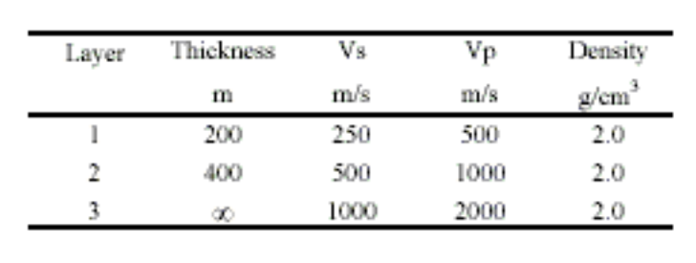

Table 2 – Mesh Statistics for DRM simulations

Concept | Step 1 – Background Calculation | Step 2 – Localized Calculation
Mesh Elements | ~69,000,000 | ~660,000
Mesh Nodes | 12,783,986 | 119,905
Interior Boundary Nodes | 5,026 | 5,026
Exterior Boundary Nodes | 5,440 | 5,440
Interior Domain Nodes | 109,439 | 109,439
Exterior Domain Nodes | 12,664,081 | -
DRM elements | - | 29,427

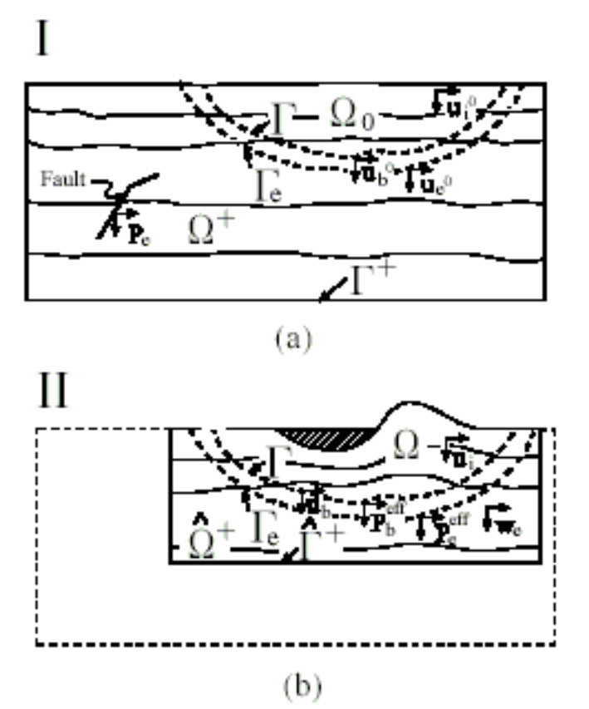

Figure 1

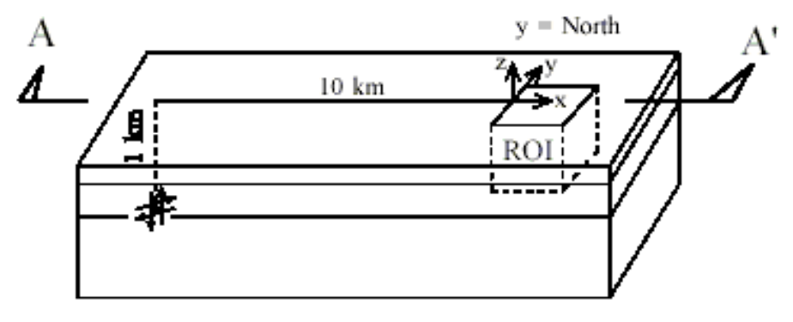

Figure 2

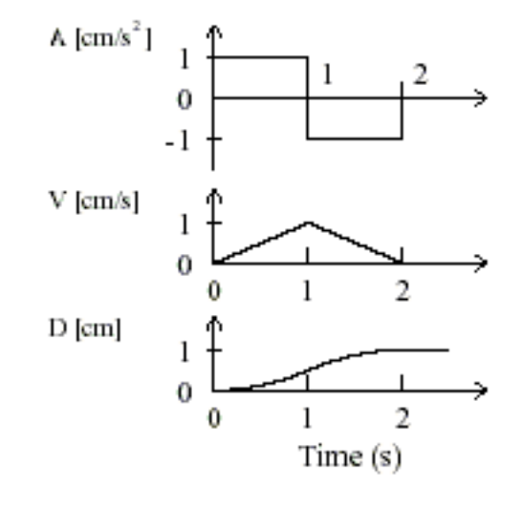

Figure 3
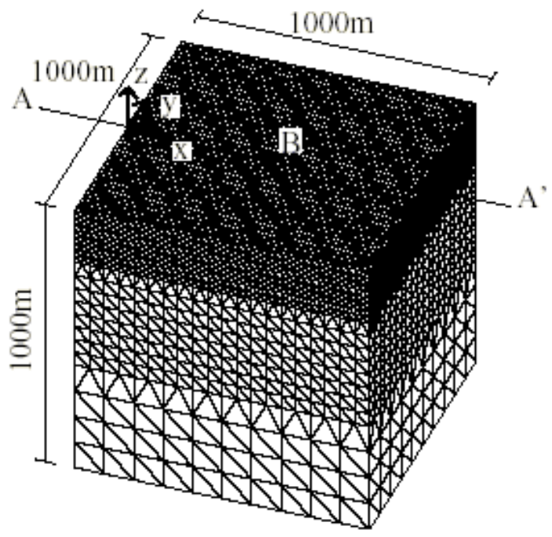
(a)
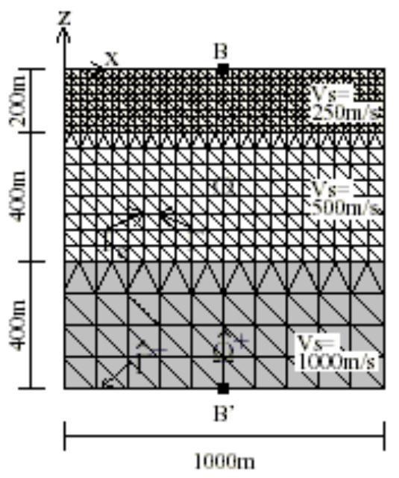
(b)

Figure 4
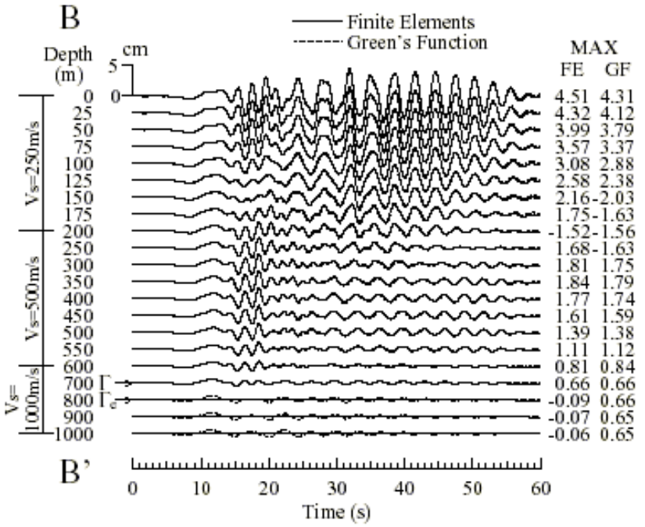
(a)
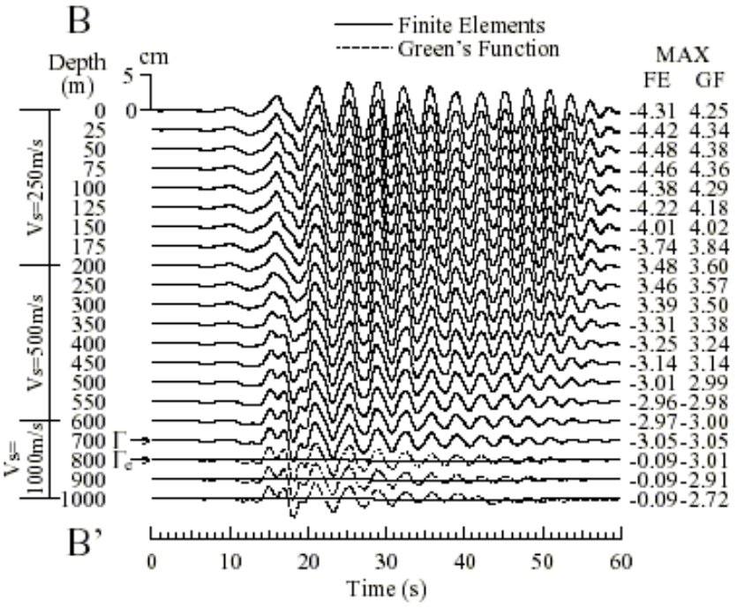
(b)

Figure 5
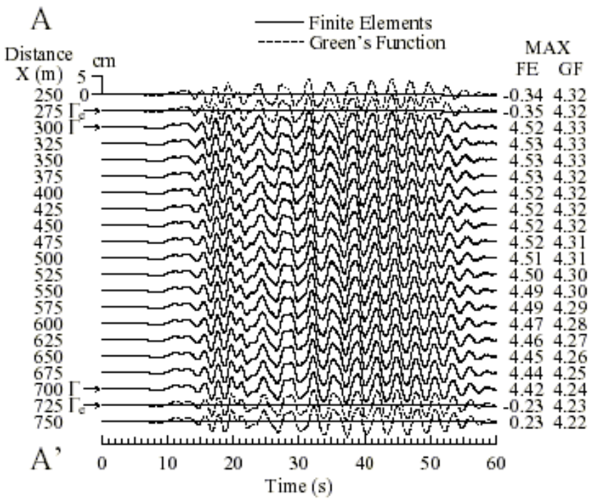
(a)
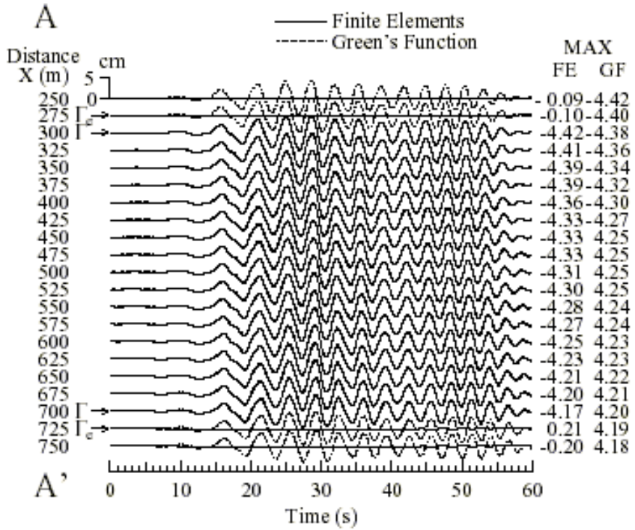
(b)

Figure 6
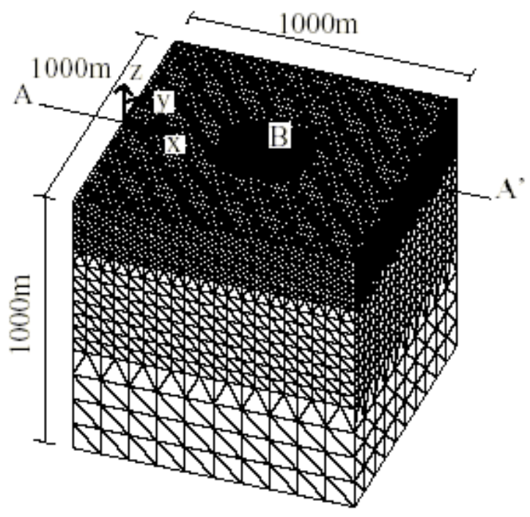
(a)
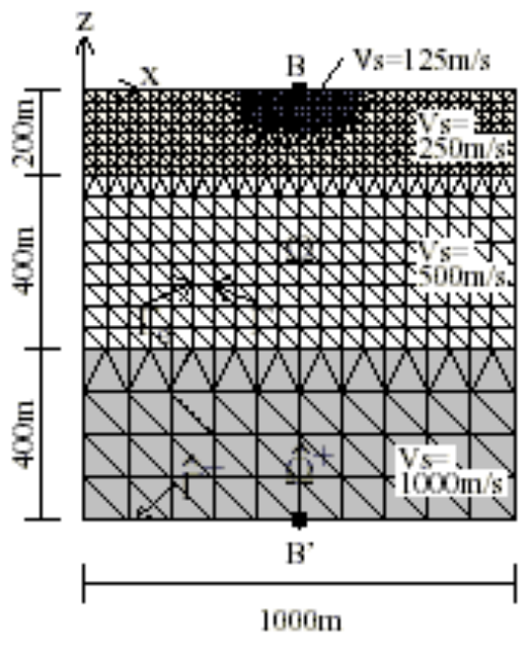
(b)

Figure 7
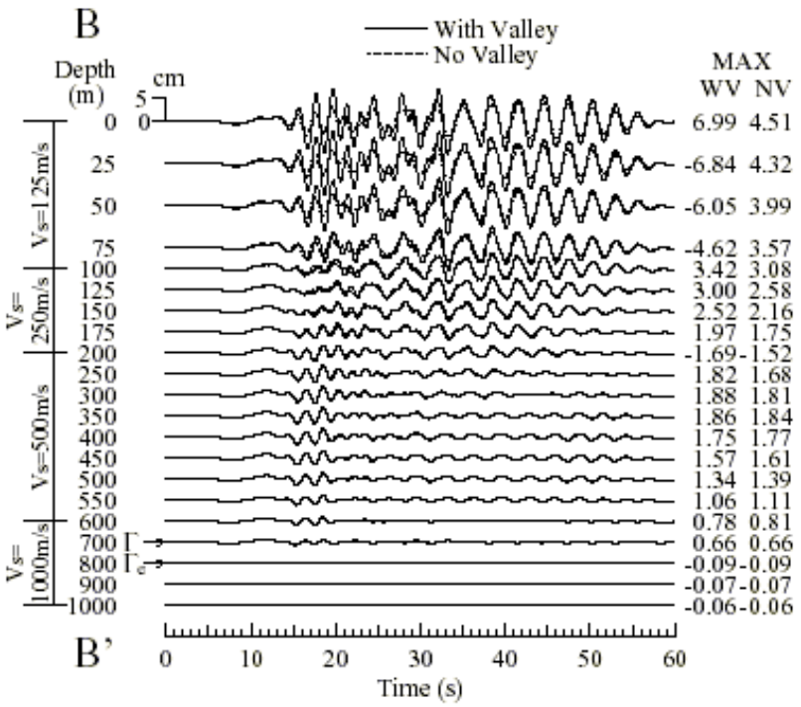
(a)
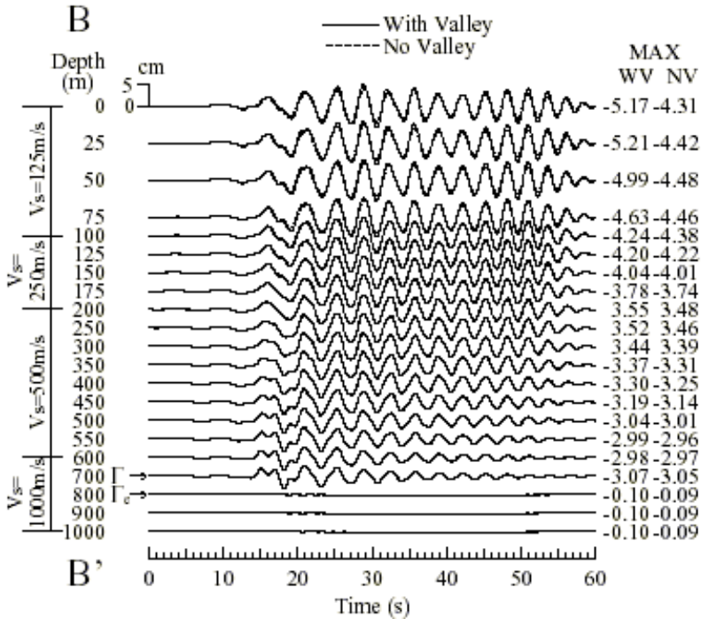
(b)
Figure 8

