Answer Key: Assignment 5

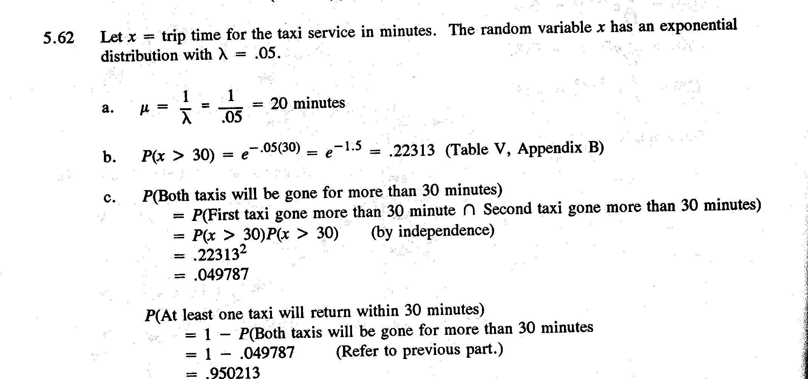

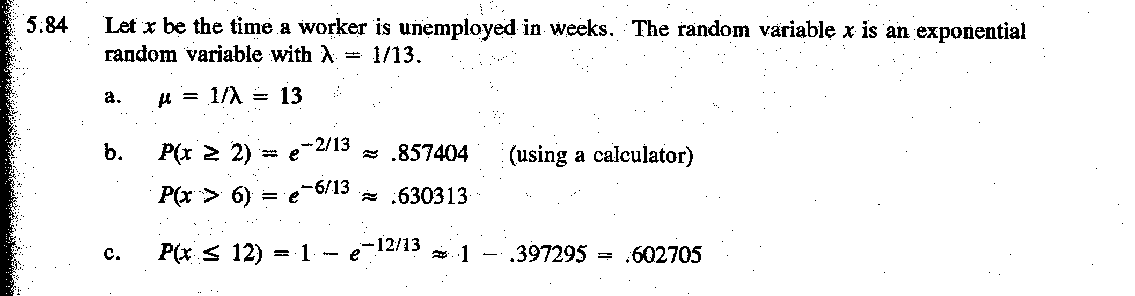

6.11 (15 points)

Histogram of Sample Mean with Size=25

Descriptive Statistics

Variable N Mean Median TrMean StDev SE Mean
C22 500 25.481 25.400 25.482 3.201 0.143

Variable Minimum Maximum Q1 Q3
C22 14.800 36.150 23.450 27.450

Sample Median Histogram with Size=25

Descriptive Statistics

Variable N Mean Median TrMean StDev SE Mean
C23 500 25.511 25.000 25.539 5.091 0.228

Variable Minimum Maximum Q1 Q3
C23 9.500 39.000 22.000 29.000

- Yes.
- The median distribution displays greater variation. StDev for sampling median distribution is 5.091 and StdDev for sampling mean distribution is 3.201.

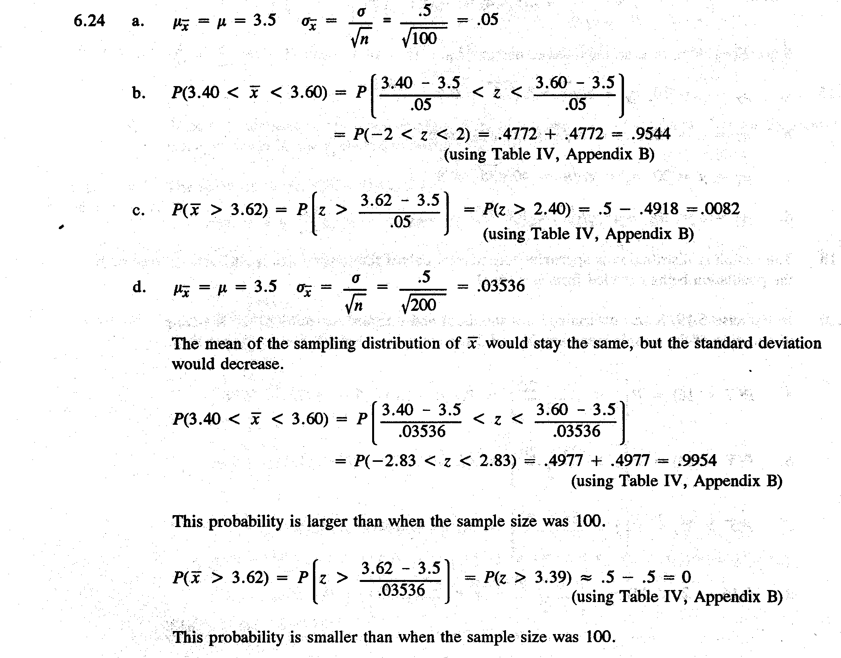

6.27 (15 points)

- According to the CLT, we will use Normal Distribution to approximate the distribution of sample mean.
$μ_{\overset{−}{x}}$=89.34
$σ_{\overset{−}{x}}$=$\frac{σ}{\sqrt{n}}$=$\frac{7\text{.}\text{74}}{\sqrt{\text{35}}}$=1.308294

- The sampling distribution should be like a Normal(89.34,1.308294)
- P($\overset{−}{x}$>88)=1-P($\overset{−}{x}$<=88)=1-0.1529=0.8471
P($\overset{−}{x}$<87)=0.0368

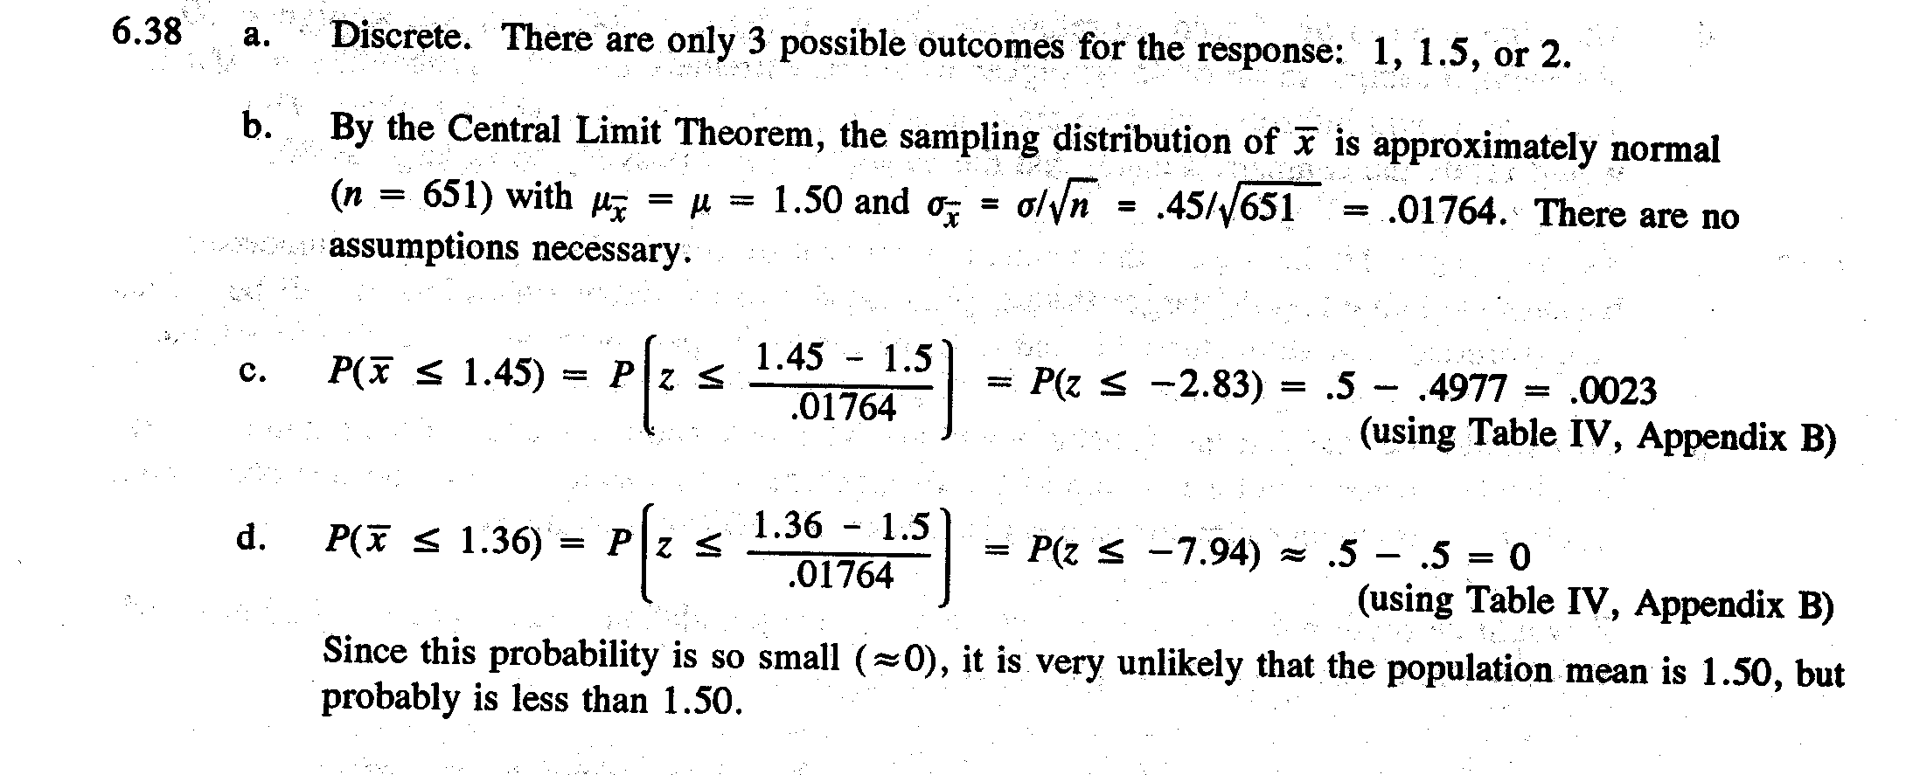
Case Book Question (15 points)
Refer to the answer of question 6.11 and workshop notes.

