- The pressure difference, ΔP, across a partial blockage in an artery (stenosis) is approximated by the equation:

Where V, is the blood velocity, μ the viscosity (FL⁻²T), ρ the blood density (ML⁻³), D the artery diameter, A₀ the area of the unobstructed artery, and A₁ the area of the stenosis. Determine the dimensions of the constants K_{v} and K_{u}. Would this equation be valid in any system of units?

Solution:
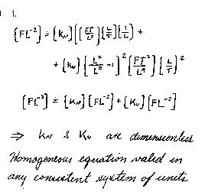

.

- Make use of table 1.2 to express the following quantities in SI units:

  - 10.2 in/min
  - 4.81 slugs
  - 3.02 lb
  - 73.1 ft/s²
  - 0.0234 (lb s)/ft²

Solution:
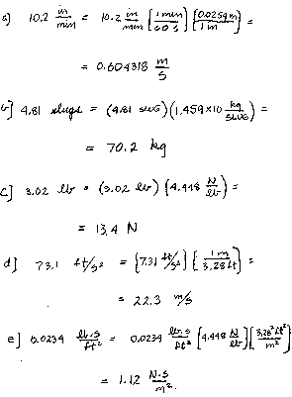

- The specific weight of a certain liquid is 85.3 lb/ft³. Determine its density and specific gravity.

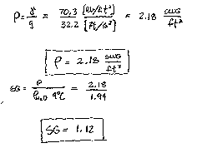
Solution:

- The density of oxygen contained in a tank is 2.0 kg/m³ when the temperature is 25ºC. Determine the gage pressure of the gas if the atmospheric pressure is 97 kPa.

Solution:
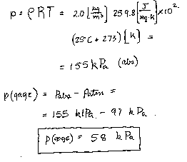

- A closed tank having a volume of 2 ft³ is filled with 0.30 lb of gas. A pressure gage attached to the tank reads 12 psi when the gas temperature is 80ºF. There is some question as to whether the gas in the tank is oxygen or helium. Which do you think it is? Explained how you arrived at your answer.

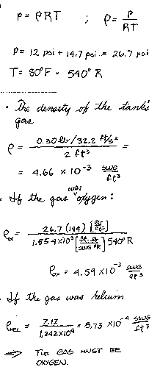
Solution:

- A compressed air tank contains 8 kg of air at a temperature of 80ºC. A gage on the tank reads 300 kPa. Determine the volume of the tank.

Solution:
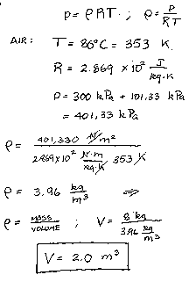

A tire having a volume of 3 ft³ contains air at gage pressure of 26 psi and a temperature of 70ºF. Determine the density of the air and the weight of the air contained in the tire.

Solution:
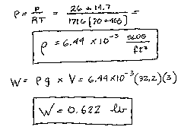

- A 10-kg block slides down a smooth inclined surface as shown in the figure. Determine the terminal velocity of the block if the 0.1-mm gap between the block and the surface contains SAE 30 oil at 60ºF. Assume the velocity distribution in the gap is linear and the area of the block in contact with the soil is 0.2 m².
0.1 mm gap
V
20º

Solution:
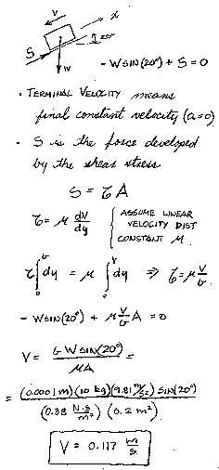

- A layer of water flows down an inclined fixed surface with the velocity profile shown in the figure and described by:
0.0442

Determine the magnitude and direction of the shearing stress that the water exerts on the fixed surface for U = 3m/s and h = 0.1m.

Solution:
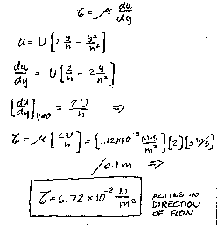

- A 25-mm diameter shaft is pulled through a cylindrical bearing as shown in the figure, The lubricant that fills the 0.3-mm gap between the shafts and the bearing is an oil having a kinematic viscosity of 8.0 x 10⁻⁴ m²/s and a specific gravity of 0.91. Determine the force P required to pull the shaft at a velocity of 3 m/s. Assume the velocity distribution in the gap is linear.

0.5 m
Shaft
Bearing
Lubricant

Solution:

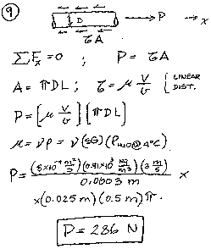

- Calculate the speed of sound in m/s for (a) gasoline, (b) mercury, and (c) seawater.

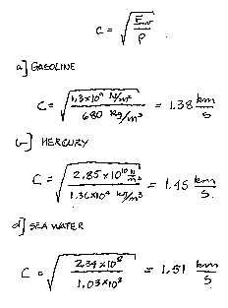
Solution:

- Estimate the minimum absolute pressure (in pascals) that can be developed at the inlet of a pump to avoid cavitation if the fluid is ethyl alcohol at 20ºC.

Solution:
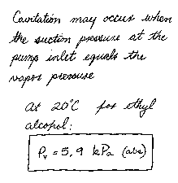

- An open, clean glass tube, having a diameter of 3 mm, is inserted vertically into a dish of mercury at 20ºC. How far will the column of mercury in the tube be depressed?

Solution:
